Governor’s Advisory Board for Telecommunications Relay Agenda
October 24, 2024 • 9:30AM – 12:00PM
Hybrid Meeting: Zoom and in the TAM office’s conference room

- Open Meeting (Chair Alfred Sonnenstrahl)
  - Roll Call
  - Approval of August 13, 2024 Minutes
- TAM Staff Reports
  - Director (David Bahar)
  - Finance (Bob Foster)
  - Maryland Relay Program/GABTR Liaison (Travis Dougherty)
  - MAT Program (Kevin Steffy)
  - Outreach Program (Donna Broadway-Callaman)
Break (10 min.)
- GABTR Chairman’s Report (Chair Alfred Sonnenstrahl)
- GABTR Members’ Reports
- Public Input
- Old Business
- New Business
  - Bylaws
- Announcements
- Adjourn
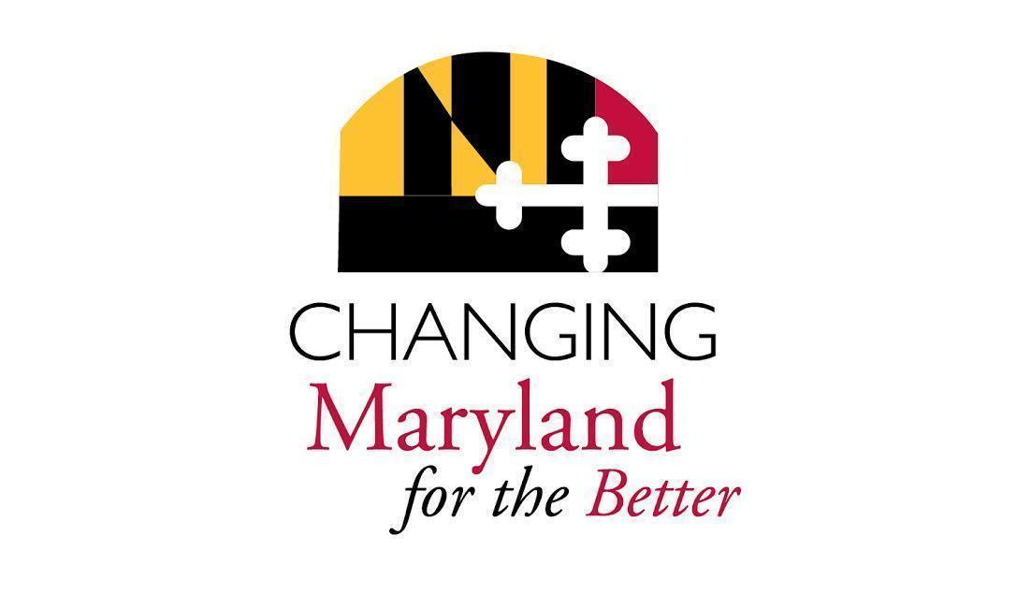
Interpreters: Chante Wilson, Anne Leahy
CART: Natalie Ennis

