MARYLAND HEARING AID &
HEARING ASSISTIVE TECHNOLOGY
RESOURCE GUIDE
2025/2026



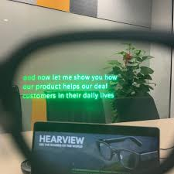
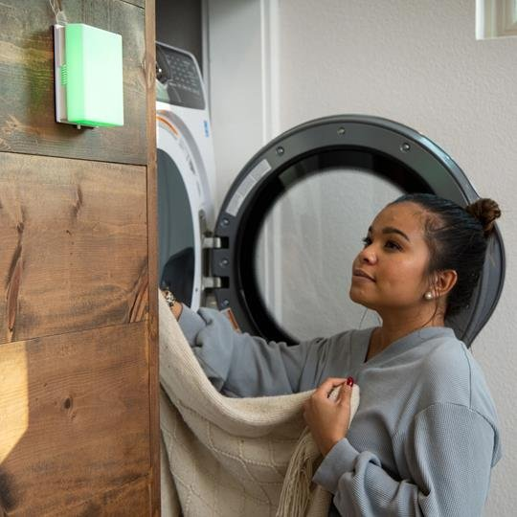

MARYLAND DEPARTMENT OF DISABILITIES
ASSISTIVE TECHNOLOGY FINANCIAL LOAN PROGRAM

WELCOME 2
ABOUT THIS GUIDE 2
DEFINING HEARING AIDS, HEARING ASSISTIVE TECHNOLOGY, ASSISTIVE LISTENING DEVICES, AND ASSISTIVE LISTENING SYSTEMS 3
HEARING IMPAIRMENT STATISTICS 4
MARYLAND AREA AUDIOLOGY CLINICS AND PROGRAMS 4
LOW-COST CLINICAL AUDIOLOGICAL ASSESSMENTS 4
FUNDING FOR HEARING AIDS AND HEARING ASSISTIVE TECHNOLOGY Up to date as of January 2025 6
HEALTH INSURANCE 6
MEDICAID 7
CHILDREN’S HEALTH INSURANCE PROGRAM (CHIP) 7
MARYLAND FUNDING RESOURCES 8
CENTERS FOR INDEPENDENT LIVING 9
NATIONAL CIVIC ORGANIZATIONS 10
OTHER FINANCING OPTIONS 11
MARYLAND DEAF AND HARD OF HEARING ADVOCACY AND RESOURCES 14
LOAN BANKS AND LENDING LIBRARIES 16
HEARING AID MANUFACTURER CONSUMER SUPPORT INFORMATION 17
COMPARING HEARING AID FEATURES 17
FINDING COMPATIBLE DEVICES 17
CONSUMER SUPPORT CONTACT NUMBERS 18
FINANCIAL MANAGEMENT RESOURCES 19
CASH CAMPAIGN OF MARYLAND 19
BUDGET CALCULATORS 20

WELCOME

"Our hope is that this guide serves as an integral resource for Marylanders who are deaf or hard of hearing as they navigate resources, services, and funding options to ensure access to hearing aids and hearing assistive technologies. With information including state, university and private resources, this guide is focused on building a framework of services from audiology assessment to identifying appropriate hearing assistive technologies. Through the work of the MD Department of Disabilities, we are creating a more equitable and inclusive Maryland."

Secretary Carol Beatty, MD Department of Disabilities

ABOUT THIS GUIDE

The Hearing Assistive Technology Funding Guide is a publication of the Maryland Department of Disabilities, Assistive Technology Financial Loan Program. This publication was made possible by a grant from the Administration for Community Living grant # 90ATTF0032-01-00. The Maryland Assistive Technology Financial Loan Program helps Maryland residents with disabilities and their families qualify for low-interest loans to buy equipment that will help them live, work, and learn more independently. No endorsements of these products, devices, services or resources are intended.

This guide is available to provide resources for consumers as they move through the process of finding or funding a hearing aid or hearing assistive technology. The differences between these devices are distinguished below. For questions related to this funding guide, please email mdtap.atlp@maryland.gov.

DEFINING HEARING AIDS, HEARING ASSISTIVE TECHNOLOGY, ASSISTIVE LISTENING DEVICES, AND ASSISTIVE LISTENING SYSTEMS

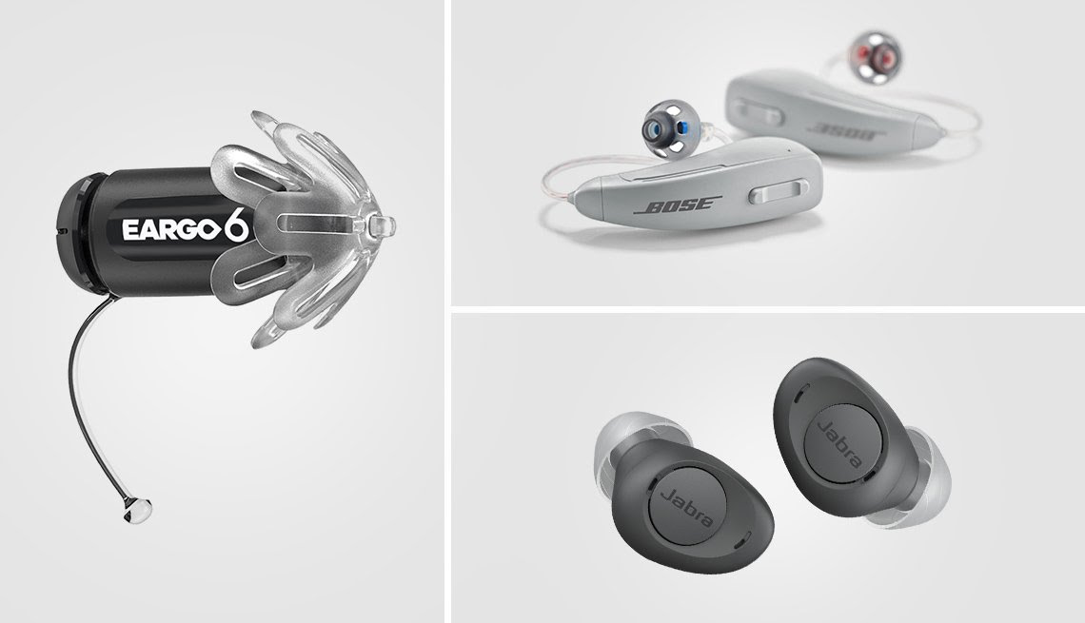
Over the Counter (OTC) Hearing Aids are available in Maryland, without a prescription, for anyone over the age of 18 with mild to moderate hearing loss. Ideally, an individual will receive a hearing test from an audiologist to determine their level of hearing loss so they will know if they are a good candidate for this type of hearing aid. Remember, your OTC hearing aid should fit well and feel comfortable!


Prescription Hearing Aids are recommended by audiologists after an audiology exam, and are often intended for severe hearing loss and anyone under the age of 18. Audiologists can also prescribe hearing aids for mild to moderate hearing loss, customized to each person's level of hearing loss.
Remember, a good hearing aid will separate voices from background noise, modulate volume, and clarify speech, and is customized to each person's level of hearing loss.

*Hearing Assistive Technology (HAT) includes a variety of devices, tools, software and equipment that can help you better understand speech, music and other sounds, so you can more fully participate in different areas of life.

Some HAT is used with hearing aids or cochlear implants, while others support anyone who wants assistance with receiving sound, including those with mild hearing loss. The HAT that will be most useful to you depends on your hearing loss and where you require communication access, whether at work, school, home, place of business or public venue. HATs help with activities of daily living/supplement to ALDs.

*Assistive Listening Devices (ALD) can help individuals with hearing loss communicate in one-to-one conversations by enhancing sound so you can understand more easily, especially in places with background noise. Examples of ALD include remote microphones, which can stream a speaker’s voice directly into hearing devices, and one-on-one personal amplifiers, which increase sound volume in face-to-face conversations or in small groups.

Assistive Listening Systems (ALS) are complete systems or setups designed to improve hearing in specific environments. An ALS typically includes both transmitting components (like microphones or sound sources) and receiving components (like devices or hearing aids). ALS help with public accessibility.


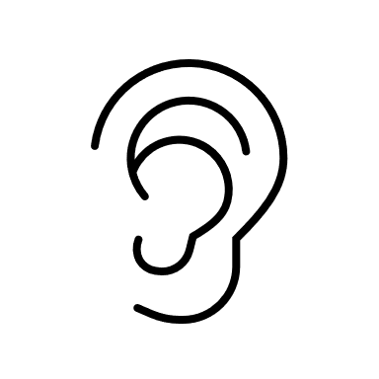
*Descriptions courtesy of the Hearing Loss Association of America

HEARING IMPAIRMENT STATISTICS

- Hearing loss is twice as common as diabetes or cancer.
- About 80% of hearing losses can be treated with hearing aids, but only 1 in 4 use them.
- Hearing aid use helps offset cognitive decline (5x greater risk with untreated hearing loss).
- 18% of those with hearing loss have depression, compared with 8% of those with normal hearing; depression improves with hearing aid use.
- The risk of falling triples with untreated hearing loss.
- About 28% of adults over 52 with hearing loss experience difficulty with daily activities, compared with 7.3% with normal hearing.
- 1 in 8 people in the United States ages 12+ have hearing loss.
- Untreated hearing loss correlated with up to $30,000 less salary. Labor statistics showed an unemployment rate of 27% of those with normal hearing, but 44% of those with hearing loss.

MARYLAND AREA AUDIOLOGY CLINICS AND PROGRAMS
Up to date as of January 2025

LOW-COST CLINICAL AUDIOLOGICAL ASSESSMENTS

Access Hears (serves seniors in Baltimore County and surrounding areas)
Phone: 443-863-9931
Email: dhill@hasa.org
Website: We Hear You Baltimore: Affordable Hearing Health Care for Older Adults

Baltimore County Government Hearing and Audiological Services (serves Baltimore County - children through seniors, sliding scale by income)
Address: 6401 York Road, Third Floor, Baltimore, Maryland 21212
Phone: 410-887-6443
Email: clinicalservices@baltimorecountymd.gov
Website: Hearing and Audiology Services | Baltimore County Government

Frederick County Health Department (serves Frederick County children only)
Address: 350 Montevue Lane, Frederick, MD 21702 Entrance C
Phone: 301-600-1611
Website: Audiology Services | Frederick County Health Department, MD

Gateway Maryland
Address: Harry & Jeanette Weinberg Building, 5900 Metro Drive Baltimore, MD 21215
Phone: 410-415-1805
Website: Gateway Maryland

Johns Hopkins Medicine Audiology Program
Phone: 443-997-6467
Website: Audiology | Johns Hopkins

Loyola University Maryland
Address: 5911 York Road, Suite 100, Baltimore, MD 21212
Phone: 410-617-1200
Email: ahatticks@loyola.edu
Website: Audiology | Loyola Clinical Centers | Loyola University Maryland

Towson University Hearing & Balance Center
Address: 7720 York Road, Towson, MD 21204
Phone: 410-704-3095
Email: iwb@towson.edu
Website: Hearing & Balance Center | Institute for Well-Being | Towson University

University of Maryland Medical Center Hearing & Balance Program
Address: 655 W. Baltimore Street, Baltimore, MD 21201
Phone: 410-328-6866
Website: Audiology | University of Maryland Medical Center


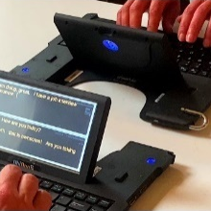
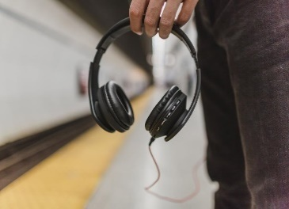
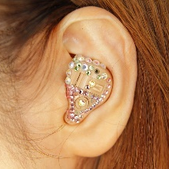
FUNDING FOR HEARING AIDS AND HEARING ASSISTIVE TECHNOLOGY

Up to date as of January 2025

For those who qualify, financing opportunities may be available to finance all or a portion of a hearing aid or hearing assistive technology.

HEALTH INSURANCE

HB1339: Health Insurance - Hearing Aids for Adults - Coverage

This bill requires insurers, nonprofit health service plans, and health maintenance organizations (collectively known as carriers) to provide coverage for all medically appropriate and necessary hearing aids for an adult covered under a policy or contract if the hearing aids are prescribed, fitted, and dispensed by a licensed audiologist. Carriers may limit the benefit to $1,400 per hearing aid for each hearing-impaired ear every 36 months. An insured or enrollee may choose a hearing aid that is priced higher than the benefit limit and pay the difference in cost without financial or contractual penalty to the hearing aid provider. The bill does not prohibit carriers from providing coverage that is greater or more favorable. The bill takes effect January 1, 2025, and applies to all policies, contracts, and health benefit plans issued, delivered, or renewed in the State of Maryland on or after that date.

MEDICAID

Maryland Medicaid may provide coverage for hearing aids, cochlear implants, and other audiological services for eligible residents. To find out more about eligibility criteria, covered services, service limitations and more, visit Welcome to Maryland Medicaid.

CHILDREN’S HEALTH INSURANCE PROGRAM (CHIP)

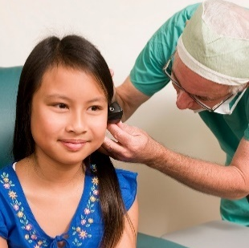
CHIP (Children's Health Insurance Program) in Maryland, which is part of the Maryland Medicaid program for children, does cover hearing aids for eligible children. CHIP provides comprehensive coverage for children who are under 19 and meet the income eligibility requirements, and it includes a wide range of health services, such as hearing aids.

Key Details About CHIP Coverage for Hearing Aids in Maryland:

- Eligibility for CHIP:
CHIP is designed for children under the age of 19 whose family income is too high to qualify for Medicaid but too low to afford private health insurance. Coverage is available to children regardless of their immigration status. If a child qualifies for CHIP, they can receive essential health services, including hearing aids. If your child is eligible, CHIP typically covers all or most of the costs for hearing aids, meaning little or no out-of-pocket expense for families.

- What CHIP Covers for Hearing Loss:
- Hearing Aids: CHIP covers the full cost of hearing aids if they are deemed medically necessary. This includes both the purchase and fitting of hearing aids.
- Hearing Evaluations: CHIP also covers hearing tests and audiological evaluations to assess the need for hearing aids.
- Follow-up Care: Coverage typically extends to follow-up visits, including maintenance and adjustments to hearing aids, to ensure proper fit and function.

- Requirements:
To obtain hearing aids through CHIP, a healthcare provider (such as an audiologist or pediatrician) must conduct a hearing evaluation and determine that hearing aids are medically necessary.
A referral or prescription from the child’s primary care provider (PCP) may be required for the hearing aids to be covered under CHIP.
- How to Apply:
Families interested in CHIP should apply through Maryland Health Connection, the state's health insurance marketplace. You can apply online, by phone, or in person at a local health department or through community partners.

Maryland Health Connection Website: Maryland Health Connection
Phone: 1-855-642-8572 (for assistance with applications)

MARYLAND FUNDING RESOURCES

Gateway Maryland (Formerly known as The Hearing and Speech Agency)
Gateway provides hearing aids offered at very reasonable prices. The styles of hearing aids include behind-the-ear (BTE), in-the-ear (ITE), and in-the-canal (CIC). The latest technology in hearing aids, programmable and digital, are also available at Gateway. Hear Now works directly with hearing aid manufacturers and provides hearing aids, for a modest fee, to individuals with extremely limited income. Gateway's audiology services are provided to Hear Now clients at reduced rates. Other audiological services offered are comprehensive hearing testing, Hearing aid evaluation and selection, fitting of custom earmolds, hearing protectors and swim plugs, simple hearing aid repairs, and Hearing aid batteries and accessories.

For more information: Gateway Maryland

Maryland Assistive Technology Financial Loan Program
The Assistive Technology Financial Loan Program helps Maryland residents with disabilities and their families qualify for low-interest loans to buy equipment that will help them live, work, and learn more independently.​ The program offers flexible lending criteria including lower income thresholds, longer repayment terms, and loan guarantees for those who qualify.
For more information: AT Low-interest Financial Loan Program

CENTERS FOR INDEPENDENT LIVING

Designed and operated by individuals with disabilities, Centers for Independent Living (CILs) provide independent living services for people with disabilities. These programs provide tools, resources, and support for integrating people with disabilities fully into their communities to promote equal opportunities, self-determination, and respect.

Maryland houses 7 CILs, each serving different counties of the state. Each CIL offers a matching-grant program, covering 70-80% of the cost of an approved home/vehicle modification or assistive device, up to between $5,000 and $8,500, depending on the CIL. This funding can be used to help finance hearing aids and hearing AT.

Independence Now (serves Montgomery and PG Counties)
Phone: 301-277-2839
Email: info@innow.org
Website: Independence Now

Bay Area Center for Independent Living (serves Caroline, Cecil, Dorchester, Kent, Queen Anne’s, Somerset, Talbot, Wicomico and Worchester Counties)
Phone: 443-260-0822
Website: Bay Area Center for Independent Living (BACIL)

The IMAGE Center of Maryland (serves Baltimore City and Baltimore and Harford Counties)
Phone: 410-982-6311
Email: info@imagemd.org
Website: The IMAGE Center of Maryland

Resources for Independence (serves Allegany, Garrett and Washington Counties)
Phone: 301-784-1774
Website: Resources for Independence

The Freedom Center (serves Carroll and Frederick Counties)
Phone: 301-846-7811
Email: advocate@thefreedomcenter-md.org
Website: The Freedom Center

Southern Maryland Center for Independent Living (serves Calvert, Charles, and St. Mary’s Counties)
Phone: 301-884-4498
Email: info@smcil.org
Website: SMCIL | Southern Maryland Center for Independent Living

Accessible Resources for Independence (serves Anne Arundel and Howard Counties)
Phone: 410-636-2274
Website: Accessible Resources for Independence

NATIONAL CIVIC ORGANIZATIONS

Civic/Service Organizations often receive charitable donations to either purchase new hearing aids and assistive devices for low-income individuals or refurbish and donate used hearing aids. The following organizations may be able to provide assistance:

Business and Professional Women’s Club
Address: 1030 15th Street, NW Unit B1-148, Washington, DC 20005-1503
Phone: 202-293-1100
Website: www.bpwusa.org
Civitan International
Address: PO Box 382857, Birmingham, Alabama 35213-0744
Phone: 205-591-8910
Email: civitan@civitan.org
Website: www.civitaninternational.com

Kiwanis International
Address: 3636 Woodview Place, Indianapolis, Indiana
Phone: 317-875-8755 ext. 411
Website: www.kiwanis.org

Knights of Columbus
Address: 1 Columbus Plaza, New Haven, CT 06510
Phone: 203-752-4000
Email: info@kofc.org
Website: www.kofc.org

Lions Association for Sight and Hearing
Address: P.O. Box 821, Bel Air, MD 21014-0821
Phone: (410) 836-6258
Website: https://www.lashmaryland.org/

Lions Club International
Address: 300 22nd Street, Oak Brook, Illinois 60523-8842
Phone: 630-571-5466 ext. 334
Website: www.lionsclubs.org

Pilot International
Address: 102 Preston Court, Macon, Georgia 31208-4844
Phone: 478-477-1208
Website: www.pilotinternational.org

Rotary International
Address: 1 Rotary Center, 1560 Sherman Avenue, Evanston, Illinois 60201
Phone: 847-866-3000
Website: www.rotary.org

Sertoma International
Address: 1912 East Myer Boulevard, Kansas City, Missouri 64132
Phone: 816-333-8300
Website: www.sertoma.org

OTHER FINANCING OPTIONS

AG Bell Association for the Deaf and Hard of Hearing offers financial aid and scholarships for all ages from infancy through adulthood for a variety of technology and services. To learn more and fill out an application: AG Bell Association.

CareCredit provides financing for the purchase of healthcare products and procedures, including hearing aids and accessories. Ask your hearing aid provider if they offer hearing aid financing through CareCredit. If they do, the application takes just a few minutes to complete when you are in the hearing aid dispenser’s office. You’ll know within minutes if you are approved. For more information: CareCredit Hearing.

The Foundation for Sight and Sound, Help America Hear Program is a national program that provides hearing aid assistance to men, women and children who have no other resources available to obtain hearing aids. For more information and to obtain an application, call 631-366-3461 or visit: Help America Hear

Ear Community is a charitable organization that helps individuals who were born with Microtia and Atresia. If you need help obtaining a BAHA (bone conduction hearing device) and have been denied by your insurance plan or can not afford to purchase one, you can apply for financial assistance on their website: Ear Community.

Hearing Aid Project believes that for those who require assistive devices, economics shouldn’t be a barrier to hearing health. Driven by the missions of organizations like Sertoma and Hearing Charities of America, and through the generosity of so many others, hearing aids are now available to those who might otherwise go without. For more information: Hearing Aid Project.

HIKE Fund, Inc., the Hearing Impaired Kids Endowment fund, will provide hearing aids or assistive devices for children with hearing impairments between the ages of newborn and 20 years whose parents are unable to pay for them. About 100 children get hearing devices each year. For more information, call 636-928-2101 or visit: The Hike Fund.

Miracle Ear® Foundation provides free Miracle Ear® hearing aids and services to adults and children from low-income families. To be eligible, the recipient must be a resident of the United States, with an income level that does not allow for public support and, in the case of a child, in a family committed to the necessary follow-up services needed as the child grows. For more information, please call 1-800-234-5422 or visit: Miracle-Ear Foundation.

Starkey Cares Better Hearing Foundation was founded on the principles of helping others by providing a more robust and equitable life experience to those who are hard of hearing. Starkey helps communities struggling to afford hearing aids by helping them acquire technologies that they wouldn’t otherwise be able to afford. They do this by offering cutting-edge hearing solutions at a dramatically reduced price. To learn more about the Starkey Cares Better Hearing program and to see if you qualify, email starkeycares@starkey.com or call 855-686-2202. You can also visit their website: Starkey.

Travelers Protective Association of America established the TPA Scholarship Trust for the Deaf and Near Deaf in 1975 to provide financial aid to children and adults who suffer deafness or hearing impairment and who need assistance in buying devices, medical or specialized treatment or specialized education, speech classes, note takers, interpreters and other services for the hearing impaired. Completed applications must be returned to the Trust by the end of each quarter: March 31st, June 30th, September 30th, and December 31st. Recipients may only receive aid once a year by completing a new application each time they seek assistance. To view the application or for more information, call 636-724-2227 or visit: TPA Hearing Trust.

United Health Care Children’s Foundation will cover up to $5,000 annually in uncovered medical expenses related to hearing loss for individuals with private insurance (not public insurance). This can help alleviate the financial burden of hearing aids, hearing-related treatments, and other associated costs that are not covered by their insurance plan. For more information or to apply for a grant: United Healthcare Children's Foundation.

United States Veterans Administration (VA) may provide hearing aids and assistive technology for veterans based on their eligibility and their degree of service-related hearing loss. Veterans must visit a local VA medical facility for services. For more information, contact the VA Health Care Benefits Center at 1-877-222-8387 or visit the Veterans Administration website to search for a local VA medical center and eligibility requirements.


MARYLAND DEAF AND HARD OF HEARING ADVOCACY AND RESOURCES

Deaf Independent Living Association Inc. (DILA)
Deaf Independent Living Association, Inc. offers free information and referral service for those who want to learn more about hearing loss, deafness and related resources. DILA can assist with applying for housing, food and healthcare assistance from the federal government and providing assistive technology for deaf and hearing loss individuals.

For more information: DILA

Disability Rights Maryland
Disability Rights Maryland (DRM), a non-profit 501(c)(3) organization, is Maryland’s designated Protection & Advocacy agency (formerly known as “Maryland Disability Law Center”). DRM is federally mandated to advance the civil rights of people with disabilities. They provide free legal services to Marylanders of any age with all types of disabilities (including sensory), who live in facilities, in the community or who are homeless.

For more information: Disability Rights Maryland

Fire and Burn Safety Coalition of Maryland (FABSCOM)
FABSCOM provides assistance to Maryland residents with a qualified need, helping them obtain a home alarm system equipped with both visual and sensory alerts to notify them if their smoke or carbon monoxide alarms are activated. To request this assistance and participate in the program, applicants must complete all required questions, certify that they are deaf or hard of hearing and submit the application. Please note that applicants residing in institutional facilities, such as dormitories, nursing homes, or assisted living centers, are not eligible for FABSCOM assistance.

For more information: fabscom-maryland
Link to the application: Our Application Process | fabscom-maryland

The Governor’s Office of the Deaf & Hard of Hearing
Provides resources and information about audiology and Speech Language Pathology, including audiology services & financial assistance.

For more information: The Governor's Office of the Deaf & Hard of Hearing MD

Hearing Loss Association of America
For 45 years, the Hearing Loss Association of America (HLAA) has been the nation’s leading, unconflicted consumer organization representing millions of people with, and at risk of, hearing loss across the U.S. HLAA offers programs, events and a nationwide community of support that give people the tools to thrive with hearing loss.

For more information: Hearing Loss Association of America

Maryland Division of Rehabilitation Services (DORS)
State vocational rehabilitation program that provides services to people with disabilities who want to work or keep their current employment. Programs and services for eligible individuals may include vocational evaluation, skills training, academic preparation and job placement assistance. People who are hard of hearing and trying to secure or retain employment may be eligible for hearing aids, assistive devices, interpreter services and more.

For more information: DORS Maryland

The Maryland Early Hearing Detection and Intervention (MD EHDI) program aims to ensure that every baby born in Maryland receives the newborn hearing screening and that hearing status is identified at the earliest age possible, preferably by 3 months of age. The MD EHDI Program coordinates with providers statewide to help ensure that babies who are identified as deaf or hard of hearing receive early intervention services, preferably by 6 months of age. ​
For more information: Maryland Early Hearing Detection and Intervention (MD EHDI) Program

Maryland Assistive Technology Program (MDTAP)
The Maryland Assistive Technology Program (MDTAP) is the statewide resource for accessing assistive technology for consultation, device demonstration, short-term lending of equipment from AT Libraries, AT training, and additional resources. MDTAP serves Marylanders of all ages and disabilities.

For more information and qualification requirements, call 410-554-9230 or 1-800-832-4827, or visit MDTAP Home.

Maryland Accessible Telecommunications (MAT) Provides free assistive telephone communications equipment to qualified Maryland residents. MAT distributes free TTYs, amplified handsets and other assistive devices to qualified applicants who have difficulty using the telephone. MAT does not provide hearing aids.
For detailed information and an application, contact Maryland Relay Customer Service at 1-800-555-7724 or visit Maryland Accessible Telecommunications (MAT).

LOAN BANKS AND LENDING LIBRARIES

Maryland offers a variety of programs that provide no-cost, short-term lending of hearing aids and assistive listening technologies, ensuring individuals have access to the tools they need to hear more clearly while navigating long-term solutions.

Maryland Assistive Technology Program (MDTAP)
MDTAP hosts 9 lending libraries across the state with hearing assistive technologies available, demonstration & consultation services, AT training, and a hightech AT reuse program. This service does not provide access to hearing aids.

To learn more about MDTAP’s Lending Libraries: Maryland Assistive Technology Program

Maryland State Department of Education Hearing Aid Loan Bank
The Maryland Hearing Aid and Language & Communication Video Loan Bank is a Statewide resource for families of children who are deaf or hard-of-hearing. Families without access through insurance or other means may borrow hearing aids for up to one year. All resources are provided to families at NO COST!
To learn more about eligibility and fill out an application: The Maryland Hearing Aid and Language and Communication Video Loan Bank

Anne Arundel County Assistive Technology Loan Program
The Americans With Disabilities (ADA) Office maintains a collection of assistive technology that is available for loan or demonstration for Anne Arundel County employees, residents, their families, professionals, and educators who work with individuals with disabilities. Participants can borrow assistive technology equipment for a maximum of 3 weeks or schedule a product demonstration with ADA staff free of charge. Staff will provide individuals with the opportunity to borrow and use the equipment to see if it meets the needs of the individual. Staff is also able to assist with locating resources to help individuals purchase assistive technology equipment. There is no cost to see or borrow devices.

To learn more or to submit a request: Assistive Technology Loan Program | Anne Arundel County Government

HEARING AID MANUFACTURER CONSUMER SUPPORT INFORMATION

COMPARING HEARING AID FEATURES
There are many kinds of hearing aids, each comprising different features, such as Telecoil, Bluetooth and FM capabilities. Audiologists usually only work with a few different brands of hearing aids, so it can be wise to research what you want out of your hearing aids and identify a specific brand prior to scheduling your audiology appointment. Resources like www.hearingtracker.com can help you to learn about what’s available and compare features.

FINDING COMPATIBLE DEVICES

To find the compatible Personal Mics or Table Mics for a specific model or serial number of hearing aids, you would need to provide the make and model of your hearing aids. Each hearing aid brand has different systems for wireless accessories, and compatibility can depend on whether the hearing aids are Bluetooth-enabled or use other wireless technologies like FM or telecoil systems.

Once you provide the details of your hearing aids, here’s the typical process you can follow to find compatible microphones and local dispensers:

1. Identify Your Hearing Aid Model and Serial Number:
You can find your hearing aid’s model and serial number in the following places:
- On the packaging or receipt if you have it.
- On the hearing aid itself (usually under the battery door or in the battery compartment).
- On any paperwork or manuals that came with your hearing aids.

2. Check the Manufacturer's Website:
- Once you know the make and model of your hearing aids, visit the manufacturer’s website (e.g., Phonak, Oticon, ReSound, Siemens, Widex, etc.).
- Manufacturers typically list compatible accessories like personal microphones (e.g., Roger Mics for Phonak or ConnectClip for Oticon).
- You can also access the user manual for information about compatible wireless devices and systems.

3. Consult a Hearing Healthcare Provider or Audiologist:
- If you don’t have access to the specific model number or need assistance determining compatibility, contact your local hearing aid provider or audiologist.
- An audiologist or dispenser can help you find the correct accessories and ensure compatibility with your hearing aids.

CONSUMER SUPPORT CONTACT NUMBERS

Oticon
855-400-9766 (Phillips)
800-327-4779 (Phillips)

Phonak
800-679-4871

ReSound
888-735-4327 (Jabra/Beltone)
800-554-2772 (Jabra)
800-925-4327 (Beltone)

Signia
800-350-6093 (Miracle Ear/TruHearing/Hearing Care Solutions/Horizon)
800-241-1372 (Miracle Ear)
786-526-0602 (Horizon)
866-212-0610 (Rexton)

Starkey
866-637-9243 or 888-481-5512 (Audibel/NuEar)
800-769-2590 (Audibel)
800-626-8327 (NuEar)

Unitron
866-230-0115 (Relate)

Widex

844-497-8844

FINANCIAL MANAGEMENT RESOURCES

CASH CAMPAIGN OF MARYLAND

The CASH Campaign of Maryland (Creating Assets, Savings and Hope) is a nonprofit organization that is the result of a merger between the CASH Campaigns of Baltimore and Maryland. As long time partners and allies, these programs joined forces to create one unified organization in July 2017.

The CASH Campaign of Maryland promotes economic advancement for low-to-moderate income individuals and families in Baltimore and across Maryland. CASH accomplishes its mission through operating a portfolio of direct service programs, building organizational and field capacity, and leading policy and advocacy initiatives to strengthen family economic stability.
The CASH Campaign of Maryland offers two great programs to help you reach your financial goals. Through generous support from the Foundation for Financial Planning and other partners, these high-quality programs are available at no cost to Marylanders.

Financial Coaching offers ongoing, unlimited, one-on-one support to reach your financial goals! The trained coaches work individually with participants and help them to achieve personal financial goals such as eliminating debt, rebuilding credit, and developing spending plans. There are no income guidelines for this program, and anyone can take advantage of this free service.

The Financial Planning Program is designed to connect Marylanders to a professional, quality financial plan on a range of topics and goals, including, investing, homeownership, college funding, and wills and retirement planning. Our Pro Bono Certified Financial Planners® provide consultations in up to two free sessions. In keeping with our mission, our aim is to serve low-to-moderate income individuals and families through this program.

Learn more and sign up for the intake survey here: Find a Financial Coach or Planner - CASH Campaign of Maryland


BUDGET CALCULATORS

Quicken:
Whether you’re new to personal finance or have been building toward financial freedom for years, budgeting can be one of your most effective tools for reaching your goals. If you want to experiment with a budget, Quicken’s free budget calculator can help you get started.

Learn more: Budget Calculator | Quicken

American Consumer Credit Counseling:
Founded in 1991, American Consumer Credit Counseling (ACCC) is a nonprofit (501) (c)(3) organization, offering confidential consumer credit counseling services, debt consolidation, debt management, budget counseling, bankruptcy counseling, housing counseling, student loan counseling and financial education to consumers nationwide. ACCC is a leader in the credit counseling industry and has national counseling experience.

ACCC offers a number of worksheets and calculators that could prove helpful:

- Household Budgeting Worksheet
- ACCC’s Budget in Your Pocket Worksheet

If you identify any inaccuracies or require modifications to this guide, please contact us at maryland.general@maryland.gov. We are committed to ensuring the information remains
accurate and up to date.

Maryland Assistive Technology Financial Loan Program

2301 Argonne Dr. Rm. T-42, Baltimore, MD 21218

Toll free: 1-800 832-4827 | Local/Relay: 410-554-9230 | Fax: 410-554-9237

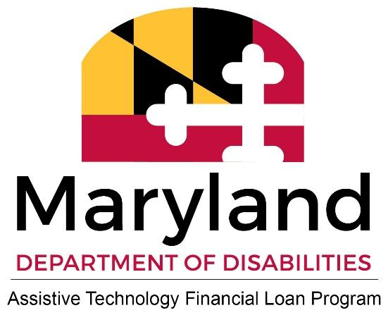
www.mdtap.org | mdtap.atlp@maryland.gov

