HOME MODIFICATIONS GUIDE OF MARYLAND

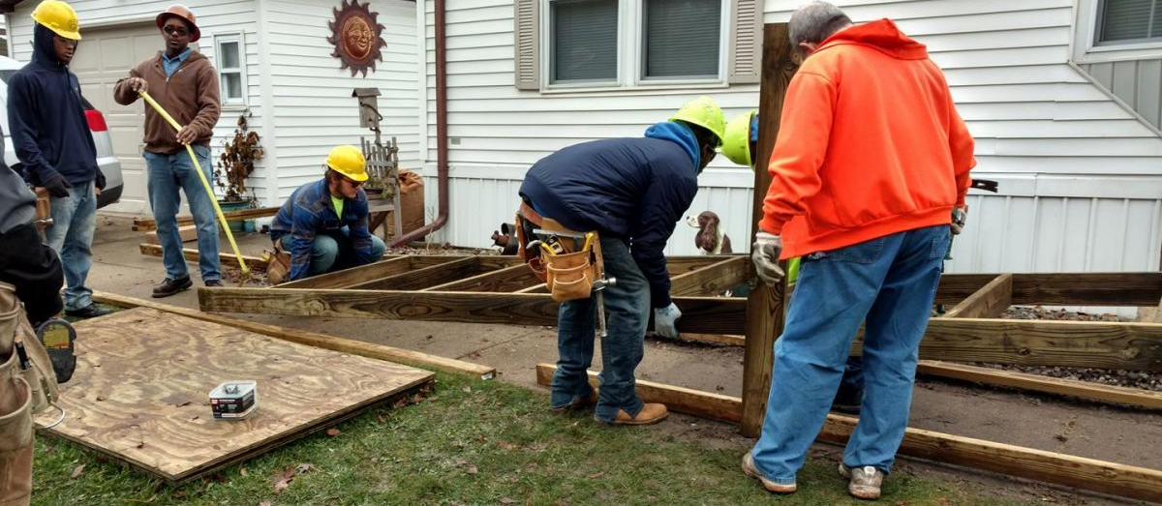
Contents
What Are Home Modifications? 2
State & Local Funding 3
Department of Housing and Community Development Programs 3
Division of Rehabilitation Services (DORS) 3
DDA Medicaid Waiver 3
Veterans Administration Programs 4
Anne Arundel County Accessibility Modifications Program 4
Assistive Technology Financial Loan Program 4
Housing Upgrades to Benefit Seniors (HUBS) 4
Baltimore County Age Friendly Upgrades for Seniors (BCAUSE) 4
Housing Accessibility Modification Program (HAMP) 5
Howard County Reinvest Renovate Restore Program 5
Centers for Independent Living ILATS Matching Grants 5
Centers for Independent Living: 5
Volunteer Organizations 6
Rebuilding Together 6
Christmas in April 6
Habitat for Humanity Metro Maryland 7
Environmental Assessment Providers 7
Finding a Contractor 7
Equipment Lending/Reuse 7
Portable & Modular Ramps 8
Assistive Technology/Smarthome Tech 9
3D Printed Equipment 9
Mainstream Adaptive Furniture 10
Tax Benefits 10
Federal 10
State 10
Local 11
ADA Tax Credit for Business 11
Housing Resources 11
Advocacy & Rights 12

WHAT ARE HOME MODIFICATIONS?

- Home Modifications are physical changes to the home that make it safer,
more accessible and more usable for someone with a disability.
- These can include equipment installation, structural design alterations,
repairs to damaged elements of the home and more.
- Home Modifications can make it possible for a person to live independently
in their own home rather than entering into an assisted living institution.
- Home Modifications can be expensive and difficult to access unless able
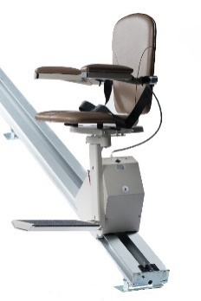
to pay out of pocket – but some help is available.
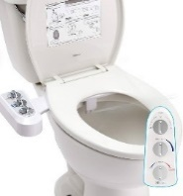
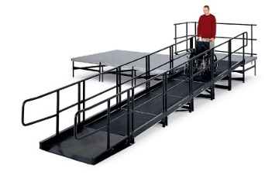
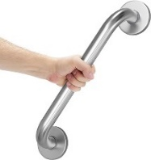

STATE & LOCAL FUNDING

Department of Housing and Community Development Programs
● Accessible Homes for Seniors
The Maryland Department of Housing and Community Development offers a program for accessibility related improvements to the homes of seniors. These improvements may include, among others, the installation of grab bars and railings, widening of doorways and installation of ramps. Home improvements such as these represent for many older people the key to remaining in their home and maintaining their independence.​
The program provides zero percent interest, deferred loans for a term of 30 years or grants to finance accessibility improvements.
● Maryland Housing Rehabilitation Program
The Maryland Housing Rehabilitation Program aims to provide affordable funding to address critical health and safety issues and bring properties into an agreement with applicable building codes and standards.

Division of Rehabilitation Services (DORS)
DORS can provide a limited range of home modification services to the homes of DORS consumers who need these services to achieve their employment goal. All services take place in the participants' homes.
Learn more about DORS services and eligibility

DDA Medicaid Waiver
Maryland Medicaid offers a Community Pathways Waiver for
- Older adults
- People with disabilities and
- Children with chronic illnesses.
This waiver can include funding for Environmental Assessments and Adaptations, or home modifications. There may be long waiting lists for approval, so it’s wise to apply early.

Veterans Administration Programs
- Home Improvements/Structural Alterations (HISA) Program
- Specialty Adapted Housing (SAH) Grant

Anne Arundel County Accessibility Modifications Program
Offers a zero-interest, deferred payment loan for qualified homeowners. The Program offers a comprehensive approach to helping homeowners address accessibility modification repairs. ACDS oversees the entire process from application intake, to assisting with the contractor selection, to construction completion.

Assistive Technology Financial Loan Program
The financial loan program offered by the Maryland Department of Disabilities’ Assistive Technology Program. Helps people qualify for and receive discounted interest rates on financial loans for assistive technology, home and vehicle modifications and adapted and non-adapted vehicles. Reach out to mdtap.atlp@maryland.gov or 410-554-9244, or apply online.

Housing Upgrades to Benefit Seniors (HUBS)
A program headed by Civic Works that employs a collaborative effort with a few different organizations to help older folks in Baltimore City obtain needed home modifications. Reach out for more information at hubsintake@civicworks.com or 443-470-9871, or apply online through the Department of Housing and Community Development's Online Application Portal. City homeowners age 65+ with lower income may be eligible.

Baltimore County Age Friendly Upgrades for Seniors (BCAUSE)
Baltimore County Age-Friendly Upgrades for Seniors (BCAUSE) is a partnership with the Baltimore County Department of Aging, Civic Works, CHAI, Dundalk Renaissance, and Rebuilding Together. Adults 65 years old or older are encouraged to apply. The program is no cost to help homeowners age in place. Contact the Maryland Access Point of Baltimore County at 410-887-2594 and be sure to ask about the BCAUSE program.

Housing Accessibility Modification Program (HAMP)
Provides financial assistance to Baltimore County homeowners and tenants with disabilities so their rental units can be modified to meet their accessibility needs.

Howard County Reinvest Renovate Restore Program
The RRR Home Rehabilitation Loan Fund Program is intended to assist income eligible Howard County homeowners with making necessary repairs and can improve overall neighborhood appearance in some cases. Can include accessibility modifications. Interest rates 2% or lower.

Centers for Independent Living ILATS Matching Grants

There are seven Centers for Independent Living (CILs) in Maryland, each providing numerous services for disabled Marylanders. Each CIL offers a matching-grant program, providing funding to cover 70-80% of an approved accessibility modification project or piece of equipment, up to between $5,000 and $8,500, depending on the county
of residence of the applicant.

Centers for Independent Living:
Centers for Independent Living (CILs) are non-profits operated by and for people with disabilities. CILs can help you get the resources you need for home modifications through funding assistance, equipment lending and information and referral services. There are seven centers in Maryland, each serving different counties:
● The IMAGE Center: 410-982-6311 - Serves Baltimore City, Baltimore County, and Harford County
● Independence Now: 301-277-2839 - Serves Prince George’s and Montgomery counties
● Resources for Independence: 301-784-1774 - Serves Garrett, Allegany, and Washington Counties
● Accessible Resources for Independence: 410-636-2274 - Serves Anne Arundel and Howard Counties
● The Freedom Center: 301-846-7811 -Serves Frederick and Carroll Counties
● Southern Maryland Center for Independent Living: 301-884-4498 – Serves St. Mary’s, Calvert and Charles Counties
● Bay Area Center for Independent Living: 443-260-0822 - Serves all 8 counties on the Eastern Shore from Somerset to Kent

VOLUNTEER ORGANIZATIONS

Rebuilding Together
A volunteer-run, national organization providing hands-on support to individuals and families in need to make necessary safety and accessibility repairs and modifications to their homes at no charge. Find your local affiliate here.

Christmas in April
A volunteer organization that repairs the homes of older adults who are either low-income and/or disabled so they may live safely, and independently. After months of planning and preparation, Christmas in April culminates in a one day repair effort on the last Saturday in April.
Christmas in Paril - Prince George’s County
Christmas in April – Cecil County
Christmas in April – St. Mary’s County

Habitat for Humanity Metro Maryland
Offering home safety and accessibility rehabilitation for families in need.
- Home Accessibility Rehab Program
- College Park Aging in Place
- Home Repair Program
- PG County Homeownership Preservation Program
- Repair and Accessibility Modification Program
- Veterans Repairs
- Weatherization Program

ENVIRONMENTAL ASSESSMENT PROVIDERS

Environmental assessment providers are professionals who specialize in looking at a home or other physical space and making specific recommendations for changes that can be made to make it as accessible as possible for someone. Find one by searching the internet, or start with one of the following directories:
Certified Aging in Place Specialists - National Association of Home Builders Directory
Home Modification Occupational Therapy Alliance - Organization of occupational therapists throughout the world that specialize in home modifications.
Maryland Access Point Directory – Contact your local Maryland Access Point for information on local housing and assessment resources.

FINDING A CONTRACTOR

National Association of Home Builders Directories – Searchable databases of professionals, including contractors specializing in accessibility and aging in place.
Better Business Bureau Directory – Searchable database of accredited businesses, including general contractors and construction services.
Maryland Access Points (MAPs) - MAP specialists work with caregivers, professionals, and all individuals with long-term care needs to plan, identify, connect, and assist with accessing private and public resources for long-term services and supports.​

EQUIPMENT LENDING/REUSE

Maryland Durable Medical Equipment Reuse Program – Provides donated, used durable medical equipment for free to Maryland residents in need.
Howard County Equipment Loan Library – Provides loaner durable medical equipment for free on a temporary basis to residents of Howard County, MD.
Howard County Safety Net Supply Closet – The Howard County Public School System maintains a closet of safety equipment aimed at supporting safety for people who may elope. Items available to borrow include door locks, childproofing supplies, and GPS tracking devices.
Maryland High-Tech Assistive Technology Reuse Program – Provides used high-tech assistive technology devices for free to Maryland residents in need.
Equipment Connections for Children – Provides used equipment for free to children and families in need in Maryland.
Ryan’s Place Foundation – Provides used durable medical equipment to children and families in need
*None of the above programs accept nor provide donated stair lifts

PORTABLE & MODULAR RAMPS

Portable Ramps are smaller, transportable ramps intended to be used for low thresholds on a temporary basis. They can be used to cover curbs, lips and entrances with about 1-3 stairs, and require little to no installation.
Modular Ramps are larger and provide a more stable, longer-term solution, but are still pre-fabricated. They require moderate installation and can cover entrances and thresholds with a larger number of stairs.
Portable Ramp Loaner Program: Each of the 7 Centers for Independent Living in Maryland can provide free, loaner portable ramps that can be borrowed for a number of months by Maryland residents in the counties they serve. Find your county’s Center for Independent Living in the “State & Local Funding” section of this document.
Rentals: Many companies offer rentals of portable and modular ramps for a monthly fee. Local providers can be found by internet search, or by contacting your county’s Maryland Access Point or 211.

US Access Board: ADA Guidelines for Ramps

ASSISTIVE TECHNOLOGY/SMARTHOME TECH

What Is Assistive Technology?
Assistive Technology is any implement that helps someone with a disability do the things they need and want to more easily. This includes things that help someone’s home work better for them, from low-tech items like a lever doorknob, to mid-tech things like a clap-on light, to high-tech devices like smart home controls.

Maryland Assistive Technology Program (MDTAP) – Providing access to assistive technology services to all Marylanders with disabilities, older adults, their families and service providers. Services include assistive technology libraries across the state, AT demonstrations, consultations, short-term device loans, a high-tech AT Reuse Center (to access gently used equipment for free), trainings, webinars, and a low-interest financial loan program. Also provides one-on-one information & referral to help consumers find needed disability-related services.
Maryland Accessible Telecommunications Program – Provides free, individualized consultations and equipment for accessible telecommunications, like adaptive phones, tablets and braille devices, to qualified Maryland residents.

3D PRINTED EQUIPMENT
Some simple, low-tech home modifications can be fabricated using 3D printing. These might include doorknob or light switch adapters, house key handles, faucet extender attachments and so forth. Some programs will 3D print assistive equipment for you at little to no cost.
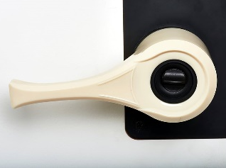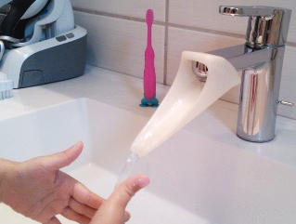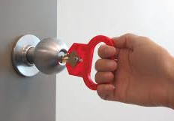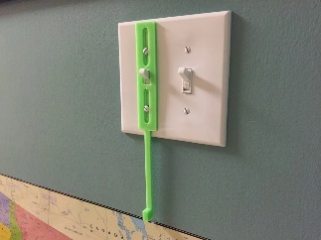

Maryland Assistive Technology Program 3D Printing Lab – Provides free, 3D printed assistive devices to Maryland residents.
Makers Making Change – Open-source network of 3D printers that provide assistive devices to people nationwide at low to no cost.
Public Library 3D Printing – Many public library branches offer free 3D printing services to anyone with a library card. Reach out to your local branch to see what’s available!

Makerspaces
There is a growing network of Makerspaces in Maryland, which are community spaces filled with equipment that members can learn about and utilize, often including 3D printers. Seek out your nearest Makerspace to learn about 3D printing your own equipment!

MAINSTREAM ADAPTIVE FURNITURE
Ikea Baesingen Series
Pottery Barn Accessible Home Series
Target Kids’ Adaptive Shop

TAX BENEFITS

FEDERAL
You can deduct the cost of home modifications on your federal income tax if they are medically necessary. You need a written recommendation from a doctor to prove the expense is needed due to a disability or medical condition for yourself, a spouse or a dependent. If a medically necessary home modification does not increase the value of your property, you can deduct the full cost. If it adds value to your property, you can deduct the differences between the cost of the modifications and the value it adds to the property.

STATE
Maryland Independent Living Tax Credit -The Maryland Department of Housing and Community Development administers a State of Maryland tax credit for residents of the state who have renovated a home to be more accessible. The tax credit may be up to 50% of the cost of the renovation up to $5,000, whether it’s your own home, the home of a family member, or a rental property.

LOCAL
Howard County Government Livable Homes Tax Credit Program is available to Howard County Residents who are owners of real property. These residents are eligible to apply for credit for approved modifications to their homes. Examples of approved modifications include ramps, stair glides, and modifications to doorways and bathrooms.
Montgomery County Design for Life Tax Credit is available to Montgomery County homeowners and contractors who purchase or make accessibility modifications to the home. Credit is received after building permit is issued and work is completed and certified by DPS.

ADA TAX CREDIT FOR BUSINESSES
A special tax credit is available to help smaller employers make accommodations required by the ADA. More details and appropriate forms can be found online at the IRS website.

HOUSING RESOURCES

St. Ambrose Housing Center - Have supported hundreds of families across the region to build generational wealth through a comprehensive range of services, including an in-house real estate brokerage, financial and home-purchase counseling, legal assistance, and access to down payment support. This work counteracts the region's legacy of
discriminatory real estate practices by design, and has strengthened neighborhoods throughout Baltimore.
Comprehensive Housing Assistance Inc. (CHAI) - A nonprofit organization serving the northwest Baltimore community. Strengthening neighborhoods for 40 years through housing and community development.
Maryland Inclusive Housing - Helping people with Intellectual and Developmental Disabilities (IDD) successfully access and maintain inclusive, affordable, and accessible housing of their choice by creating opportunities, identifying resources, connecting people and providing services.
Community Choice Homes (CCH): Provides affordable rentals for people with extremely low incomes in Montgomery County, in partnership with the Housing Opportunities Commission and Maryland Department of Disabilities.
Local Public Housing Authorities by Maryland County
University of Maryland Online Housing Toolkit

ADVOCACY & RIGHTS
Disability Rights Maryland - Provides free legal services to Marylanders of any age with all types of disabilities (developmental, intellectual, psychiatric, physical, sensory, learning, traumatic brain injury), who live in facilities, in the community or who are homeless.
Mid-Atlantic ADA Center - The Mid-Atlantic ADA Center provides information, guidance, and training on the Americans with Disabilities Act (ADA), tailored to meet the needs of businesses, government entities, organizations, and individuals in the Mid-Atlantic Region (DC, DE, MD, PA, VA, and WV).

Maryland Assistive Technology Program,
Maryland Department of Disabilities

2301 Argonne Drive
Baltimore, MD 21218
410-554-9230 (Voice)
1-800-832-4827 (Voice)
1-866-881-7488 (TTY)
410-554-9237 (Fax)
Mdtap.general@maryland.gov (E-mail)
www.mdtap.org (Web Site)

The Home Modifications Resource Guide is a publication of the Maryland Department of Disabilities, Assistive Technology Program (MDTAP). This publication was made possible by Grant Number 90AG0006-01-00 from the Administration for Community Living. MDTAP is governed under the provisions of Public Law 108-364, and is provided as a cooperative service of the Department of Disabilities. MDTAP provides information on available products, devices, services and other resources to assist individuals with disabilities. No endorsements of these products, devices, services or resources are intended.

This publication is available in alternative formats
upon request.
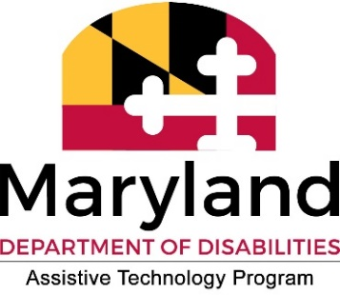

Wes Moore, Governor ~ Aruna Miller, Lt. Governor
Carol A. Beatty, Secretary ~ Anne Blackfield, Deputy Secretary

