Carol A. Beatty, Secretary
Anne Blackfield, Deputy Secretary

Wes Moore, Governor
Aruna Miller, Lt. Governor

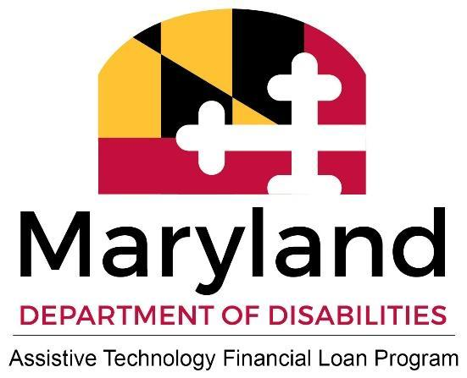

Meeting Title: BOD ATLP MANDATORY Meeting
Date: February 19, 2026
Location: Virtual Meeting
Attendees: Heather Ferguson -MDOD-, Sarah Calhoun -MDOD-, Lori Berrong -MDOD-, Andrew Drummond -DoIT-, Dominique Sessa, Liz Lyles, Jeff Le, Jessica Stine, Michele Hunter, Rich Bauernschub, Toyin Fasakin.

Section |  | Details
Call to Order 7:08 pm |  | Chairperson Dominique Sessa called the meeting to order. A second was moved by Toyin. All participants were reminded to identify themselves before speaking.
Policy Question Clarity |  | Discussion of the three previously posed policy questions was postponed due to a lack of offline collaboration and unclear directives. Staff (Lori Berrong -MDOD- and Heather Ferguson -MDOD-) are committed to providing clear instructions and resending the task for board collaboration, with responses due by next Tuesday.
Lending Software and Policies Review |  | A subcommittee (Michele, Rich, Liz) presented research findings after the acquisition of new lending software. The core finding was that while program actions largely comply with federal and state guidelines, the language in current documents needs updating to align with statutes and ensure nondiscriminatory practices. Michele will send the research findings document to the Board.
Joint Applicants and DTI Policy |  | The Board discussed potential policy changes regarding the Debt-to-Income (DTI) ratio, specifically combining the income and debt of joint applicants regardless of shared residency (contrary to historical practice). The primary applicant DTI threshold and the joint applicant debt combination policy were postponed for a Board review and vote because the current policy manual's clarity was questioned. The BOD will vote electronically on a proposed change
Automobile Minimum Debt ($300) |  | The discussion reviewed the $300 minimum debt figure added to automobile loan applications. Consensus was reached to review current data, specifically average car insurance rates in Maryland and other vehicle-related costs, to inform the board's decision on whether to adjust the figure, which was last increased in 2021.
Completed Application Definition |  | The language in the Policy and Procedures manual will be revised to reflect the Board's definition of a complete application. The Board discussed and determined that a complete application requires the signature, attached identification, and answers to application questions for each applicant and the AT User. Verification of income and proof of disability are required only as conditions of approval, not for application completion. This will be updated in the manual, which currently states that a complete application includes all requested attachments, such as proof of income and disability. All Board members verbally agreed to this definition and clear language.
Applicant Letters/Communication |  | The Board is to review applicant correspondence templates for potential changes, including clarity of language and the inclusion of the Equal Credit Opportunity Act (ECOA) statement. Heather Ferguson -MDOD- will send a packet of current and proposed letter examples with clear review instructions.
Engagement and Communication |  | Suggestions for improvement included using alternative platforms such as Google Slack or Microsoft Teams for immediate Board Member communication, holding more in-person meetings, and establishing bylaws to define operations and ensure continuity. Toyin requested a switch from Google Meet to Zoom or Microsoft Teams for better accessibility.
Capacity and Bylaws |  | Three open-board positions (finance seat, disability seat, and agency-appointed representative seat) were announced, and efforts to fill them began immediately.  A subcommittee is needed to draft new bylaws, with a first draft or outline expected by June 2026. The Board also discussed and agreed to adopt a regular cadence (semi-annual or quarterly) for reviewing policies and procedures.
Vice Chair Position |  | Dominique Sessa nominated Michele Hunter for the Vice Chair position, who will take time to consider the offer. The need for a co-chair was agreed upon, and Toyin seconded Dominique's nomination.
Decisions & Action/Voting Items
Key Decisions (ALIGNED)

- Policy Directive: A new email will be sent with clear, exact instructions defining the required outcome for each of the three policy points.
- Application Definition: The policy manual will be updated to state that verification of income and proof of disability are conditions of approval, not requirements for a complete application.
- Meeting Platform: Future online Board meetings will explore using Zoom or Microsoft Teams for improved accessibility.
Items for Further Discussion/Review/Vote
- Joint Applicant Debt Combination Policy: Will be voted on by the Board. After the discussion, board members agreed that this policy needs to be examined by the Board, and they will be given the opportunity to discuss and vote.
- Maximum over the guidelines DTI: The board was asked whether they wanted to establish a maximum DTI above the threshold that would disqualify an applicant from adding a joint. (A recent application was used as an example.) Each member verbally disagreed with this idea; a vote is required
- Bylaws Subcommittee: A subcommittee must be formed to draft bylaws, with the first draft/outline due by June 2026. A request for Subcommittee volunteers will be sent.
- Policy and Procedures Review Cadence: The board will be asked to vote on establishing a semiannual or quarterly review cadence, to be included in the bylaws.
- Vice Chair Nomination: Michelle Hunter is considering the Vice Chair nomination and will communicate her ideas and decisions.
- Working Board Retreat: The ATLP staff will consider holding working board retreats.
Action Items
Owner | Task | Deadline/Timeline
Dominique Sessa | Coordinate with the board to discuss and provide answers/solutions to the three policy questions presented in late October. | DUE
Lori Berrong | Send out the updated email to the Board with a clear directive for the three policy questions. | ASAP
Michele Hunter | Send the subcommittee's research findings to the group for the Board's records. This document is to be reviewed by the Assistant Attorney General, the MDOD Deputy Secretary, and the ATLP Staff. Communication with the subcommittee will be ongoing, and updates will be provided to the Board as they become available. | ASAP
Heather Ferguson | Send out an example template for correspondence to applicants (current and prospective), including language for the Equal Credit Opportunity Act statement. | March 2026, working with Keen 360 software developer
Lori  Berrong | Research the average car insurance rates in Maryland to inform the decision on the $300 minimum debt figure. | TBD
Heather Ferguson &  Sarah Calhoun | Explore Zoom or Microsoft Teams for future meetings. Find a location to host the next in-person/ retreat meeting. | TBD
Board Members | Volunteer for the Bylaws Subcommittee.
Michele Hunter | Consider the nomination to serve as Vice Chair. | ASAP
Jessica Stine | Share a personal story about assistive technology at the next meeting. | Date TBD

Adjournment | 9:19 p.m. | The meeting was adjourned upon motion by Dominique Sessa, seconded by Jeff.

