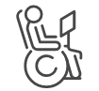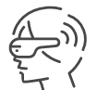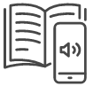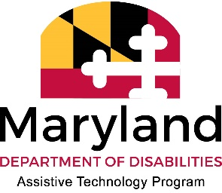

# Maryland Assistive Technology (AT) Services at a Glance

# *AT for Education*

## AT: Levels of Tech for the Classroom

Assistive Technology (AT) is any implement that helps someone with a disability do something more easily. This can include low-tech aids, like a visual schedule, mid-tech aids, like an electric speller, or high tech devices, like eyegaze systems, complex AAC, software and apps. AT can be manufactured with the purpose of being used as AT, or something can *become* AT when augmented or used creatively.

## Considering AT for Your IEP?

We provide in person & virtual AT demonstrations, and offer multiple ways to explore AT solutions for any need. We work with students, ADA Coordinators, educators, parents and more!

## Try Before you Buy!

Borrow AT from any of our AT public libraries to get hands-on experience with equipment and find out what works, or practice accommodations with a student before making a purchase. We can even ship devices to you for free!

## Looking for Recommendations?

We provide individualized consultations to students (and others!) interested in exploring AT solutions, virtually and in-person.

## Ready to Get Your AT?

We host programs that can help you find gently used, working AT at low or no cost. You can also utilize our low interest financial loan program to buy equipment!