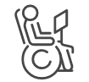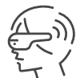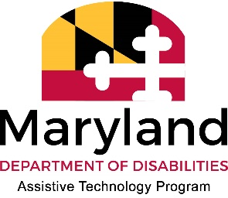

# Maryland Assistive Technology (AT) Services at a Glance

*AT for Business*

## What Is AT? Levels of Tech for the Workplace

Assistive Technology (AT) is any implement that can help someone with a disability do something more easily. This can include low-tech items like a signature guide, mid-tech devices like an adaptive computer mouse, or high tech devices like complex communication systems, software and apps. Things can be manufactured with the intent of being AT, or can *become* AT when augmented or used in an innovative way.

## Exploring AT for Your Work, or for an Employee?

We host AT Libraries across the state, provide in person & virtual AT demonstrations, and offer multiple ways to explore AT solutions for any need. We work with individuals, employers, service providers, families and more.

## Try Before you Buy!

Borrow AT from any of our AT public libraries to get free, hands-on experience with equipment to find out what you like, or discover what accommodations will work for an employee before making a purchase. We can even ship devices to you for free!

## Looking for Recommendations?

We provide individualized consultations to anyone interested in exploring AT solutions.

## Ready to Get Your AT?

We host programs that can help you find gently used, working AT at low or no cost. You can also utilize our low interest financial loan program to buy equipment!