Home Modifications Directory

Of Maryland
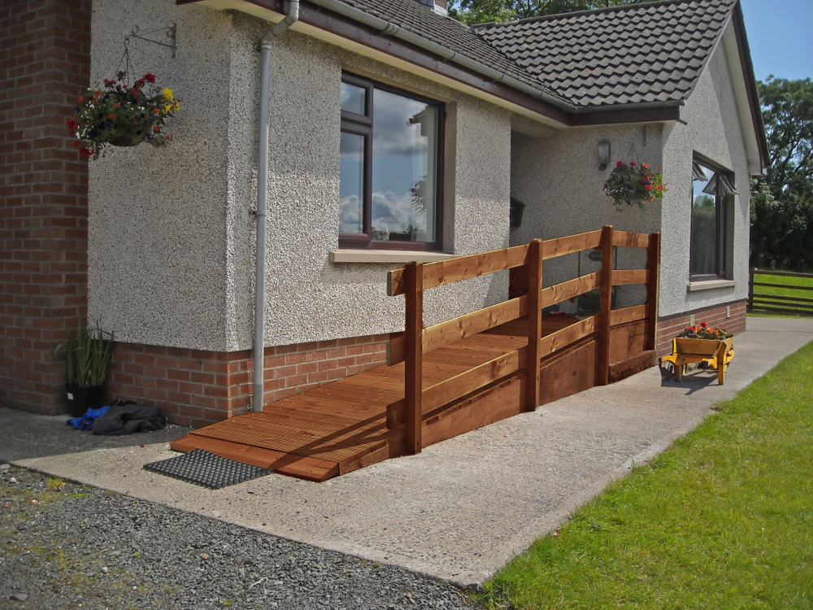
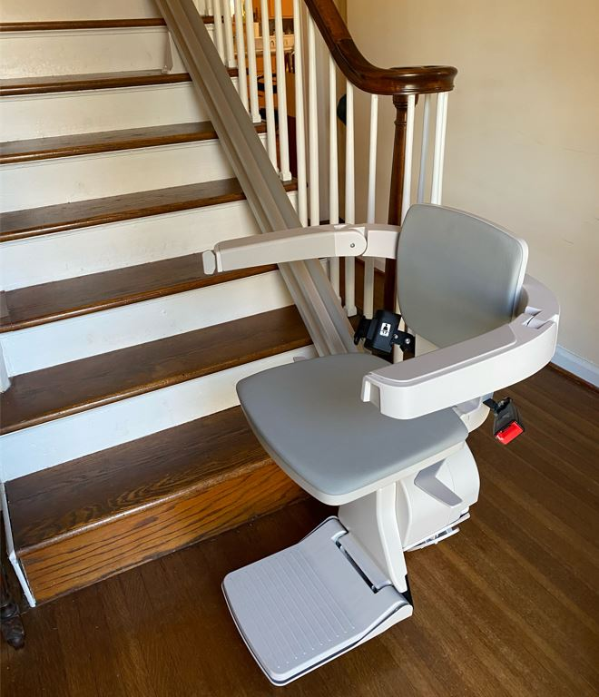

Wes Moore, Governor ~ Aruna Miller, Lt. Governor
Carol A. Beatty, Secretary ~ Lisa Belcastro, Deputy Secretary

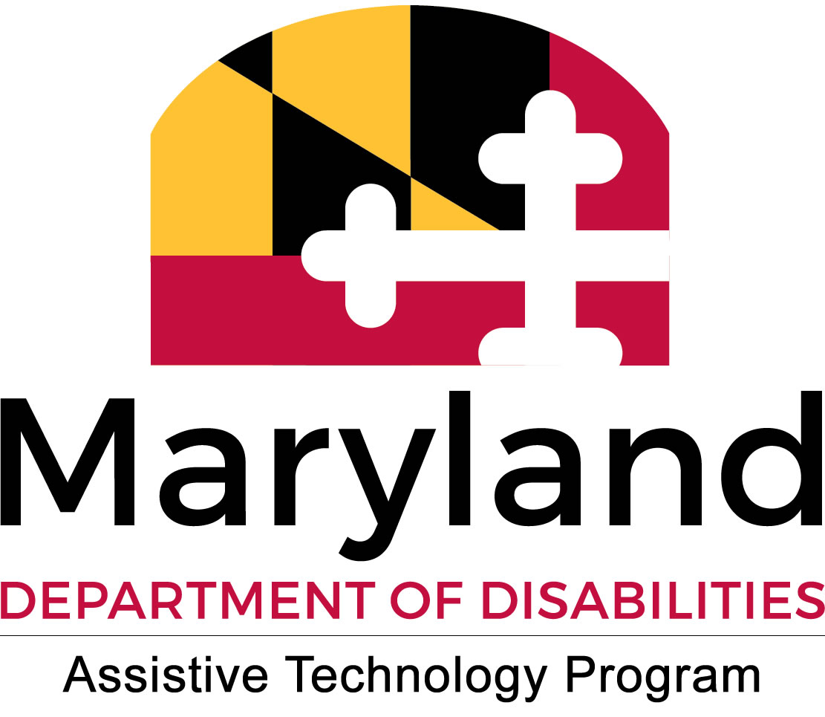
Maryland Assistive Technology Program,
Maryland Department of Disabilities

2301 Argonne Drive
Baltimore, MD 21218
410-554-9230 (Voice)
1-800-832-4827 (Voice)
1-866-881-7488 (TTY)
410-554-9237 (Fax)
Mdtap.general@maryland.gov (E-mail)
www.mdtap.org (Web Site)

The Home Modifications Resource Guide is a publication of the Maryland Department of Disabilities, Assistive Technology Program (MDTAP). This publication was made possible by Grant Number 90AG0006-01-00 from the Administration for Community Living. MDTAP is governed under the provisions of Public Law 108-364, and is provided as a cooperative service of the Department of Disabilities. MDTAP provides information on available products, devices, services and other resources to assist individuals with disabilities. No endorsements of these products, devices, services or resources are intended.

This publication is available in alternative formats upon request.

Table of Contents

Funding for Home Modifications………………………………………………….….4

Tax Benefits……………………………………………………………………….…4-5

Federal and State Financing……………………………………………………….5-6

Maryland Centers for Independent Living………………………………………..…6

Web Resources……………………………………………………………………......6

Correction Page.……………………………………………………………………….7

Index…………………………………………………………………………………….8

Funding Home Modifications

Most people pay privately for home modifications, but some sources can help you pay for home modification and repairs. This guide includes information on loans (which must be paid back to the lending institutions), grants (money provided for free), and labor organizations that provide the materials, construction, and labor to build or conduct the home modifications at no cost to the consumer.

Tax Benefits

Federal
You can deduct the cost of home modifications on your federal income tax if they are medically necessary. You need a written recommendation from a doctor to prove the expense is needed due to a disability or medical condition for yourself, a spouse or a dependent. If a medically necessary home modification does not increase the value of your property, you can deduct the full cost. If it adds value to your property, you can deduct the differences between the cost of the modifications and the value it adds to the property.

State
Maryland Independent Living Tax Credit -
The Maryland Department of Housing and Community Development administers a State of Maryland tax credit for residents of the state who have renovated a home to be more accessible. The tax credit may be up to 50% of the cost of the renovation up to $5,000, whether it’s your own home, the home of a family member, or a rental property.

Local
Howard County Government Livable Homes Tax Credit Program is available to Howard County Residents who are owners of real property. These residents are eligible to apply for credit for approved modifications to their homes. Examples of approved modifications include ramps, stair glides, and modifications to doorways and bathrooms.

ADA Tax Credit for Businesses
A special tax credit is available to help smaller employers make accommodations required by the ADA. More details and appropriate forms can be found online at the IRS website.

Resources on the Web
NOTE: if you do not have Internet access, you may request copies of these materials from Maryland TAP at 1-800-832-4827 (voice/TTY).

“How to Build Wheelchair Ramps for Home” is a manual of design and construction for modular wheelchair ramps. This manual includes information about ramps and long-tread low-riser steps to improve safe home accessibility. The manual is available through the Metropolitan Center for Independent Living for $15.00. Videos are also available on accessible building. For ordering information, please call 651-603-2029.
Web site: http://www.klownwerkz.com/ramp/default.htm

The Center for Universal Design is a national center that evaluates, develops and promotes accessible design in building and related products.
Website: www.ncsu.edu/ncsu/design/cud/about_ud/udprinciples.htm
Correction Page

We have supplied a correction page in an attempt to catch any mistakes that may have slipped by our editors, and to note changes in information for our next update to this Directory. Please fax or mail any changes or corrections to us using this sheet. Thank you!

Name:

Address:

Telephone

Page Were Correction/Change is needed:

Corrected Information:

Please fax to: 410-554-9237

E-Mail: mdtap.general@maryland.gov

Or mail to: Maryland Assistive Technology Program
Workforce and Technology Center
2301 Argonne Drive, Room T-42
Baltimore, MD 21218

INDEX

Federal and State Financing……………………………………………………………..

Equipment Supplies…………………………….….………………..………...………… 10-14

Funding Sources and Loans Program…………………………………..…...………... 15-21

Home Assessment/Equipment Evaluation………………………………...………….. 22-26

Information and Referral……………………………………………………....………… 27-29

Licensed Home Improvement Contractors...……………………………..….……….. 30-40

Volunteer Organization………………………………………………….…...………….. 41-45

FEDERAL & STATE FINANCING

Federal Resources

Community Development Block Grant (CDBG) Program
The CDBG program provides annual grants on a formula basis to entitled cities, urban counties and states to develop viable urban communities by providing decent housing and a suitable living environment, and by expanding economic opportunities, principally for low- and moderate-income persons. Some local housing agencies utilize portions of their CDBG program to pay for various kinds of home modifications. To contact your local CDBG grantee, call the US Department of Housing and Urban Development at (202) 708-1112, or visit: www.hud.gov/local/md/community/cdbg/index.cfm or www.usc.edu/dept/gero/nrcshhm/directory/md.htm

HOME
HOME provides formula grants to States and localities that communities use—often in partnership with local nonprofit groups—to fund a wide range of activities that build, buy, and/or rehabilitate affordable housing for rent or homeownership or provide direct rental assistance to low-income people. For more information visit: www.hud.gov/offices/cpd/affordablehousing/programs/home

State Resources

Maryland WholeHome
The Maryland Department of Housing and Community Development (DHCD) offers loans for home modifications. The purpose of the Maryland WholeHome Program is to preserve and improve single-family properties by providing access to funding to correct exterior and interior deficiencies; make modifications for increased home accessibility (grab bars, ramps, etc.); correct health and safety violations; improve weatherization and energy conservation; and correct lead-based paint violations. For more information contact: 1-800-638-7781.

Accessible Homes for Seniors
The Maryland Department of Housing and Community Development (DHCD), in partnership with the Maryland Department of Aging (MDoA), coordinated a project to promote accessibility related improvements to the homes of seniors, allowing seniors to remain in their homes and maintain independence. The program provides zero percent interest, deferred loans for a term of 30 years to finance accessibility improvements. The program is available throughout the State and marketed through the Area Agencies on Aging.

Maryland Medicaid Waivers
Most states offer Medicaid programs that cover home modifications to enable elderly and / or individuals with disabilities to remain living at home. Some waivers pay for assistive technologies such as special equipment for a washroom and adaptive lighting. Other waivers pay for physical modifications to the home, such as the addition of wheelchair ramps, stairlifts, and walk-in or wheelchair accessible bathtubs and showers. These modifications are more formally referred to as Environmental Accessibility Adaptations. Please note, unlike nursing home Medicaid, waivers are not an entitlement. (An entitlement means that anyone eligible will receive care). Typically, waiver programs have limited participant enrollment. And sometimes waiting lists exist for services. For a complete list of Medicaid Waivers in Maryland that include home modifications, click here.

HomeAbility
HomeAbility is a special product designed to assist Maryland homebuyers with disabilities to finance their home purchase. This loan product is made available through the Maryland Department of Housing and Community Development.

Centers for Independent Living

Maryland Centers for Independent Living can help you get the resources you need for home modifications. There are seven centers in Maryland:
- IMAGE Center 410-982-6311 serves Baltimore City, Baltimore County, and Harford County;
- Independence Now serves Prince George’s and Montgomery, 301-277-2839;
- Resources for Independence, 301-784-1774, serves Garrett, Allegany, and Washington Counties;
- Freedom Center, 301-846-7811, serves Frederick and Carroll Counties;
- Southern Maryland Center for Independent Living, 301-884-4498, serving St. Mary’s, Calvert and Charles Counties;
- Bay Area CIL serving all 8 counties on the Eastern Shore from Somerset to Kent; and Accessible Resources for Independence, (410) 636-2274 serves Anne Arundel and Howard Counties.

EQUIPMENT SUPPLIES

Accessible Living, A Division of Metropolitan Bath and Tile
6806 Laurel Bowie Rd.
Bowie, MD 20715
Phone: 301-835-1736
Email: bowie@metrobath.com
Website: https://metrobathandtile.com/accessible-living/
Description: Home Modifications, Accessible Living, Aging in Place, Barrier
Free Bathrooms, Roll-In Showers, Universal Design Kitchens, Universal Design Bathrooms, Ceiling Lifts & Ceiling Tracking Systems, Stair Lifts/Glides, Platform Lifts, Wheelchair Lifts, Automated Door Opening Systems, Grab Bars, Ramps, Lighting, Handrails, Decks, Widen Doorways, Widen Hallways, Relocate Switches, Medi-Tubs, Walk-in Tubs, Residential Elevators, etc. MHIC #129895
Type: Equipment Supplies
Counties: Howard, Montgomery, Prince George’s, Anne Arundel, Baltimore, Carroll, Frederick, Harford, Queen Anne’s, Talbot, Calvert, Charles

American Medical Equipment
733 Fredrick Road
Catonsville, MD 21228
Phone: 410-719-1222
Fax: 410-719-6676
Website: www.amedeq.com
Description: Specializes in sales and installation of stair lifts/glides. Also sells and installs modular ramps and sells portable ramps.
Type: Equipment Supplies
Counties: All Maryland Counties

Area Access- Manassas
7131 Gateway Ct. Manassas, VA 20109
Phone: 703-396-4949 or 1-800-333-2732
Fax: 703-396-4950
Website: www.areaaccess.com
Description: Mobility equipment supplier and installer, including residential elevators, stair lifts, lift chairs. Licensed by the MHIC.
Type: Equipment Supplies
Counties: All Maryland Counties

Area Access- Richmond
2207 Tazewell Street, Richmond VA. 23222
Phone: 804-355-7102
Website: www.areaaccess.com
Description: Mobility equipment supplier and installer, including residential elevators, stair lifts, lift chairs. Licensed by the MHIC.
Type: Equipment Supplies
Counties: All Maryland Counties

Area Access- Norfolk
2812 Cromwell Drive, Norfolk VA.23509
Phone: 757-852-2732
Website: www.areaaccess.com
Description: Mobility equipment supplier and installer, including residential elevators, stair lifts, lift chairs. Licensed by the MHIC.
Type: Equipment Supplies
Counties: All Maryland Counties

Bedco Mobility, Inc.
6300 Falls Road, Unit 2, Baltimore, MD 21209
Phone: 410-825-1440
Email: info@bedcomobility.com
Website: https://www.bedcomobility.com
Description: Install and service accessibility equipment including residential stairlifts, wheelchair lifts, home elevators, adaptive driving aids such as hand controls, spinner knobs and left foot accelerators, van and scooter lifts. They also sell and rent wheelchair accessible vans.
Type: Equipment Supplies

Counties: All Maryland Counties

NuMotion
2700 Lord Baltimore Drive, Baltimore, MD 21244
Phone: 410-298-4555 or 800-777-6981
Fax: 410-298-1642
Website: https://www.numotion.com/locations/baltimore-md
Description: Custom rehab equipment
Type: Equipment Supplies

Counties: All Maryland Counties

Choice Marketing & Sales, Inc.
1393 Tanyard LN Pasadena, Maryland 21122
Phone: 1-888-761-8780 or 410-761-8787
Fax: 410-437-8077
E-Mail: choicedisabilities@verizon.net
Description: Stair and vehicle lifts, equipment evaluation and repair, home assessment and renovations, vehicle sales
Type: Equipment Supplies
Counties: All Maryland Counties

RCM
965 Baltimore Annapolis Blvd
P.O. Box 1199
Severna Park, Maryland 21146
Phone: 888-353-8878
Fax: 410-544-1137
Website: https://rcmelevators.com/
Description: Installation and maintenance of elevators, stair/chair lifts, and other durable medical equipment.
Type: Equipment Supplies
Counties: All Maryland Counties

The Scooter Shop
6360 South Hanover Rd. Suite B
Elkridge, MD 21075
Phone: 877-224-2294 or 443-832-0069
E-Mail: jim@yourscootershop.com
Website: www.yourscootershop.com
Description: Sells and services durable medical equipment.
Type: Durable Medical Equipment Supplier
Counties: Baltimore City, Baltimore County, Howard County, Anne Arundel County, Carroll County, Montgomery County, Harford County, Cecil County, Prince George’s County, Maryland, and Washington DC.

Atlantic Door Control/ASSA ABLOY
9550 Berger Road
Columbia, MD 21046-1513
Phone: 410-290-9500 or 800-899-2324
Fax: 410-290-9575 (Sales & Administration) or 410-290-8775 (Service Division)
Website: www.atlanticdoorcontrol.com
Description: An international company that sells commercial and residential automatic sliding doors, apartment doors, swinger doors, etc.
Type: Equipment Supplies
Counties: International

Total Mobility Services
5415 Yukon Court, suite E
Frederick, MD. 21703
Phone: 240-490-7840
Website: www.tmservices.com
Description: New, used and rental wheelchair vans, adapted driving equipment, high tech driving equipment, sales & service, ramps, elevators, ceiling lifts, mobility products.
Type: Equipment Supplies
Counties: Frederick, Montgomery, Washington, Carroll, Prince George’s

USA Rehab
105 Sudbrook Ln.
Baltimore, MD 21208
Phone: 410-653-3903
Fax: 410-653-6996
E-mail: shara@usa-rehab.com
Website: www.usa-rehab.com
Description: Sells modular ramps, portable lifts, grab bars, etc.
Type: Durable Medical Equipment Supplier
Counties: All Maryland Counties

Wheel Pad
14 Castle Hill Rd,
Wilmington, VT 05363
Phone: 802-464-3957
Email: rj@wheelpad.com
Website: https://www.wheelpad.com
Description: Wheel Pad designs home attachments and backyard tiny houses that make any property a safe and cozy universally accessible place for people with mobility challenges. We aim to help people stay in their homes: whether they are seeking to age in place, recover after an accident, or quickly add more square footage for a growing and changing family. Wheel Pad has two main products: The +Add PAD home attachment and the Personal Accessible Dwelling (Affectionately, The PAD) accessible tiny house. Both of these models exceed ADA specifications. They come with a track in the ceiling that is compatible with any lift on the market that can take you from the bed area to the bathroom. The bathroom itself is a full wet room to avoid transitioning in and out of the shower, and allows ample space for an aide if needed. The PAD also has an accessible kitchenette for more independent living.
Type: Durable Medical Equipment Supplier
Counties: All Maryland Counties

FUNDING SOURCES AND LOAN PROGRAMS

Assistive Technology Financial Loan Program
MDTAP
2301 Argonne Drive, Room T-42
Baltimore, MD 21218
Phone: 410-554-9230 or 1-800-832-4827
TTY: 1-866-881-7488
Fax: 410-554-9237
E-Mail: mdtap.atlp@maryland.gov
Website: www.mdtap.org
Description: Aids Maryland residents with disabilities and their families in qualifying for low-interest loans to purchase assistive technology. No fee to apply for a loan.
Type: Funding Sources and Loan Programs
Counties: All Maryland Counties

BCAUSE, Baltimore County Age Friendly Upgrades
400 Washington Avenue
Baltimore, MD 21204
Phone: 410-887-2109
E-Mail: afbc@baltimorecountymd.gov
Website: https://www.baltimorecountymd.gov/departments/aging/programs-services/age-friendly
Description: Baltimore County Age-Friendly Upgrades for Seniors, BCAUSE, helps seniors over the age of 65 remain in their homes as they age. To be eligible for the program, a person needs to be a Baltimore County homeowner who is 65 years or older and is at or below 50 percent of area median income.
Type: Funding Sources and Loan Programs
Area: Baltimore County

CHAI: Comprehensive Housing Assistance, Inc.
5809 Park Heights Avenue
Baltimore, MD 21215
Phone: 410-500-5300
Fax: 410-466-1996
E-Mail: info@chaibaltimore.org
Website: www.chaibaltimore.org
Description: Provides loans and grants to low and moderate income seniors 62+ and individuals with disabilities for home repairs, modifications and safety and OT evaluations. Services limited to Northern Park Heights neighborhoods in the 21215 zip code.
Type: Funding Sources and Loan Programs
Area: Neighborhoods of Falstaff, Glen, Mt. Washington, Cross Country, Pikesville, Randallstown and Cheswolde

Centers for Independent Living
7 CILs serving all counties in Maryland
Website: https://www.ilru.org/projects/cil-net/cil-center-and-association-directory-results/MD
Description: The CILs across Maryland provide assistive technology matching grants to help fund the cost assistive technology, including the cost related to home modifications for accessibility. Amount of grant varies amongst each CIL.
Type: Funding Sources and Loan Programs
Area: All Maryland Counties

Developmental Disabilities Administration (DDA) – Main Branch
201 W Preston Street, Suite 422 4th Floor
Baltimore, MD 21201
Phone: 410-767-5600
Fax: 410-767-5850
Website: dda.health.maryland.gov
Description: The Developmental Disabilities Administration funds a variety of services for people who have developmental disabilities, including determining eligibility for services and medical waivers. Some services and waivers include funding home modifications and assistive technology. See branch information below.
Type: Funding Sources and Loan Programs

DDA - Central Maryland
Maryland Department of Health and Mental Hygiene
Central Maryland Regional Office
1401 Severn St.
Baltimore, MD 21230
Phone: 410-234-8200 or 1-877-874-2494
TTY: 1-800-735-2258
Fax: 410-234-8397
Email: bianca.renwick@maryland.gov
Counties: Anne Arundel, Howard, Harford, Baltimore County, and Baltimore City

DDA - Eastern Shore
Maryland Department of Health and Mental Hygiene
Eastern Regional Office
926 Snow Hill RD
Salisbury, MD 21804
Phone: 410-572-5920 or 1-888-219-0478
TTY: 1-800-735-2258
Email: rachel.white@maryland.gov
Counties: Caroline, Cecil, Dorchester, Worcester, Wicomico, Talbot, Somerset, Queen Anne's, and Kent

DDA - Southern Maryland
Maryland Department of Health and Mental Hygiene
Southern Maryland Regional Office
312 Marshall Ave., 7th Floor
Laurel, MD 20707
Phone: 301-362-5100 or 1-888-207-2479
TTY: 301-362-5131
Email: michael.bryan@maryland.gov​
Counties: Calvert, Charles, St. Mary's, Prince George's, and Montgomery

DDA - Western Maryland
Maryland Department of Health and Mental Hygiene
Western Maryland Regional Office
1360 Marshall St.
Hagerstown, MD 21740
Phone: 301-791-4670 or 1-888-791-0193, 1800-735-2258 (240) 313-3869
Fax: 301-791-4019
Email: Linda.yale@maryland.gov.
Counties: Allegany, Carroll, Frederick, Garrett, Washington

Division of Rehabilitation Services (DORS)
Maryland State Dept. of Education
2301 Argonne Drive
Baltimore, MD 21218
Phone: 410-554-9442 or 1-800-479-8613
TTY: 410-554-9411
Fax: 410-554-9222
Email: dors@msde.state.md.us
Website: www.dors.state.md.us
Description: DORS administers vocational rehabilitation in Maryland for people with disabilities. This program provides rehabilitation services to eligible individuals with the goal of employment. The Independent Living program serves a small number of eligible individuals whose goal is increased independence in their living arrangements. DORS provides funding for home assessments and modifications in some cases, as well as equipment evaluations. Sliding scale fees. Require documentation of financial need. Individuals with higher incomes may be required to pay some of the costs, but many pay nothing. Other possible funding sources must be explored. Ages 16 & up.
Type: Funding Sources and Loan Programs; Home Assessment / Equipment Evaluation
Counties: All Maryland Counties

Eric Fund, The
P.O. Box 65188
Washington, DC 20035-5188
Phone: 202-841-2700
E-Mail: info@ericfund.org
Website: www.ericfund.org
Description: The Eric Fund, a Washington, DC-based nonprofit, was established in memory of Eric C. Savader, a disability rights advocate who died of cancer in 1997. The goal of the Eric Fund is to help children and adults with disabilities in the Washington, DC, metropolitan area lead more independent, productive lives by purchasing assistive technology not covered by insurance or other funding streams. Twice annually the Eric Fund awards grants to deserving individuals based on financial need. Each year, the Eric Fund gives away $10,000 in assistive technology and living aids for people with disabilities in the Washington, D.C. area including Northern Virginia and Maryland.
Type: Funding Sources and Loan Programs

Help Hope Live
2 Radnor Corporate Center
100 Matson Ford RD Suite 100
Radnor, PA 19087
Phone: 1-800-642-8399
Website: www.helphopelive.org
Description: Supports community-based fundraising for people with unmet medical expenses and related costs due to cell and organ transplants or catastrophic injuries and illnesses.
Type: Funding Sources and Loan Programs
Counties: All Maryland Counties

HUBS, Housing Upgrades to Benefit Seniors
2701 Saint Lo Drive,
Baltimore, MD 21213
Phone: 410-366-8533
Fax: 410-366-1831
Email: info@civicworks.com
Website: https://civicworks.com/programs/housing-upgrades-to-benefit-seniors/
Description: Social Workers and staff members based at each site work with clients one-on-one through assessing their home modification needs and determining other community resources that may improve the quality of their lives.
Type: Funding Sources and Loan Programs
Counties: Baltimore City

Loading Dock, The
2 North Kresson Street
Baltimore, MD 21224
Phone: 410-558-DOCK (3625)
Fax: 410-558-1888
Email: kirkland@loadingdock.org
Website: www.loadingdock.org
Description: A 2100 square foot warehouse that acts as a clearinghouse for new and used building materials, which are distributed to families with low incomes and nonprofit agencies. Nominal membership fee, minimal charges for materials.
Referral Required: From Department of Social Services or a nonprofit organization.
Type: Funding Sources and Loan Programs
Counties: All Maryland Counties

Muscular Dystrophy Association
8501 LaSalle Road #106
Towson, MD 21286
Phone: 410-494-7106; 1-833-275-6321
Fax: 410-494-0082
Website: www.mda.org
Description: Helps pay for occupational therapy (OT) evaluations, which may include recommendations for home modifications. Works with designated occupational therapists. Pays a set amount for one evaluation per person per year; MDA pays up to $200 per evaluation. Serves only people with neuromuscular disorders, including muscular dystrophy.
Type: Funding Sources and Loan Programs
Counties: All Maryland Counties

National Multiple Sclerosis Society - Maryland Chapter
2219 York Rd #302,
Timonium, MD 21093
Phone: 443-641-1200 or 1-800-FIGHT-MS
Fax: 443-641-1201
Email: tod.robertson@nmss.org or info@nmss-md.org
Website: www.nationalmssociety.org
Description: The Chapter offers hands-on assistance to people with multiple sclerosis who need help navigating the complex federal, state and community programs available for people with disabilities. Assistance includes area such as services available to help people remain in their homes safely, affordable health insurance options, employment laws, and financial planning and financial assistance resources.
Type: Funding Sources and Loan Programs
Counties: All Maryland Counties

Rural Development Administration - Maryland and Delaware State Office

USDA Rural Development
Maryland/Delaware State Office
1221 College Park Drive, Suite 200, Dover, DE 19904

Phone: 302-857-3581
Fax: 855-389-2241
Contact: David Baker, State Director
Email: David.Baker3@usda.gov
Website: https://www.rd.usda.gov/de_md
Description: 504 Loan and Grant program provides 1% loans up to a maximum of $20,000 per loan to homeowners of any age who live in rural areas and have very low incomes. Sometimes have funds available for grants of up to $7,500 for rural homeowners who are 62 and older and have very low incomes. Loans and grants may be used for home modifications, purchases, and repairs. To qualify for loans, must be unable to obtain a commercial loan, have good credit and be able to repay the loan. Both programs are limited to rural areas.
Type: Funding Sources and Loan Programs
Counties: All Maryland Counties

Specially Adapted Housing for Disabled Veterans
Department of Veterans Affairs, Veterans Affairs Regional Office, 31 Hopkins Plaza, Rm 3020 Baltimore, MD 21201
Phone: 410-230-4444
Toll free: 800-446-4926
Fax: 410-203-4445
Website: https://www.va.gov/housing-assistance/disability-housing-grants
Description: Assists certain disabled veterans and retired military personnel in acquiring suitable housing units, with adapted features. Can assist in financing new construction or remodeling, or applications against an outstanding mortgage on a specially adapted home. The disability must be service connected and fall within a set of specified parameters, which includes mobility impairment.
Please call the VA before buying a house so they can examine it to see if a grant can be issued for that particular home.
Type: Funding Sources and Loan Programs
Counties: All Maryland Counties

Travis Roy Foundation
101 Huntington Ave. Suite 520, Boston, MA 02199
Phone: 617-619-8257
Email: info@travisroyfoundation.org
Website: www.travisroyfoundation.org
Description: The Travis Roy Foundation provides grants in the range of $1,000 to $5,000 for equipment, vehicle & home modifications, etc to individuals who have suffered a spinal cord injury.
Type: Funding Sources and Loan Programs
Counties: All Maryland Counties

HOME ASSESSMENT / EQUIPMENT EVALUATION

Abilities OT & Irlen Diagnostic Center
600 Reisterstown Rd #600GHI,
Baltimore, MD 21208
Phone: 410-358-7269
Fax: 443-438-9948
Email: info@aotss.com
Website: www.aotss.com
Description: Virtual and onsite home assessments and consultations. Comprehensive testing for sensory and environmental stressors and physical barriers. Office, home, classroom, and ergonomic assessments. Over 30 years of experience working with clients , caregivers and design/build professionals
Referral: Doctor's referral may be required for certain types of insurance reimbursements for home assessments
Type: Home Assessment / Equipment Evaluation
Counties: All Maryland Counties

Accessible Home Solutions, LLC
9406 Locust Hill Rd.
Bethesda, MD 20814
Phone: 703-864-6036
Website: www.AccessibleHomeSolutions.com
Description: Consultation and individualized design solutions and product recommendations for function and safety.
Type: Consultation and assessment
Area: All Maryland Counties

Division of Rehabilitation Services (DORS)
Maryland State Dept. of Education
2301 Argonne Drive
Baltimore, MD 21218
Phone: 410-554-9442
TTY: 1-866-881-7488
Fax: 410-554-9136
Email: dors@msde.state.md.us
Website: www.dors.state.md.us
Description: DORS administers vocational rehabilitation in Maryland for people with disabilities. This program provides rehabilitation services to eligible individuals with the goal of employment. The Independent Living program serves a small number of eligible individuals whose goal is increased independence in their living arrangements. DORS provides funding for home assessments and modifications in some cases, as well as equipment evaluations. Sliding scale fees. Require documentation of financial need. Individuals with higher incomes may be required to pay some of the costs, but many pay nothing. Other possible funding sources must be explored. Ages 16 & up.
Type: Funding Sources and Loan Programs; Home Assessment / Equipment Evaluation
Counties: All Maryland Counties

Easter Seals Delaware & Maryland Eastern Shore
Easter Seal Society for Disabled Children and Adults, Inc.
61 Corporate Commons Blvd. Newcastle DE 19720
Phone: 302-324-4444
Fax: 302-324-4441
Website: https://www.easterseals.com/de/
Description: A non-profit health care agency dedicated to increasing the independence of children and adults with disabilities. The Salisbury office is specifically an outpatient pediatric rehabilitation center. The Newcastle location includes an Assistive Technology resource center. All provide information and referral.
Type: Funding Sources and Loan Programs; Information and Referral
Counties: Caroline, Cecil, Dorchester, Kent, Queen Anne's, Somerset, Talbot, Wicomico, Worcester

Federal Home Solutions, Inc.
Phone: 410-409-8128 or 443-324-4419
Website: www.federalhomesolutions.com
Email: federalhomesolutions@gmail.com
Description: Full service custom remodeling company specializing in modifications for seniors and people with disabilities.
Certified Aging in Place Specialist. MHIC licensed.
Type: Funding Sources and Loan Programs; Information and Referral
Counties: Baltimore, Carroll, Harford, Howard, Anne Arundel, Montgomery, and Prince Georges

Glickman Design Build, LLC
15757 Crabbs Branch Way, Rockville, MD 20855
Phone: 301-444-4663 (MD) or 202-792-7320 (DC)
Email: Russ@GlickmanDesignBuild.com
Website: www.GlickmanDesignBuild.com
Description: Certified in accessibility consultation, design, planning and building. Offers full range of contracting for home modifications including: Design and remodeling kitchens, bathrooms, basements; creative/attractive entryways, expanding doorways; constructing ramps; installing stair glides, lifts, elevators, grab bars and remote door openers. Design/build. Fixed-rates.
Type: Expert in designing, planning and building any type of home modifications or new custom homes for special needs and aging-in-place. As the parent of a child with cerebral palsy who has lived at home in a wheelchair for over 20 years, Russ Glickman has developed a passion to serve the special needs community.
Counties: All Maryland Counties, DC, VA

Independence Now, Inc.
12301 Old Columbia Pike, Suite 101
Silver Spring, MD 20904
Phone: 301-277-2839
Fax: 301-625-9777
Website : www.innow.org
Email: info@innow.org
Description:
Prince George’s County: Operates a project which provides home assessments by an Occupational Therapist and pays for low cost home modifications. Identifies and screens contractors, leverages other resources (volunteer services, etc.) to help fund the balance of the project. Serves people with all disabilities.
Montgomery County: Provides in-home assessments by an Occupational Therapist for a fee. Both offices provide advocacy for people needing home modifications, including help with securing funding.
Type: Home Assessment / Equipment Evaluation; Funding Sources and Loan Programs; Information and Referral
Counties: Montgomery, Prince George's

Rehab at Work
6951 Golden Ring Rd
Baltimore, MD 21237
Phone: 888-827-6361 or 410-866-3855
Website: www.rehabatwork.com
Description: Provides workplace safety assessments and recommends specific workplace modifications. Onsite workplace assessments, some health insurance policies cover services.
Type: Workplace Assessment / Equipment Evaluation
Area: Anne Arundel, Carroll, Charles, Frederick, Montgomery, and Prince George's

The Right Turn Rehabilitation Services
Abingdon, MD 21009
Phone: 443-402-5490
Fax: 443-420-6747
Email: rightturn324@gmail.com
Website: www.rightturnrehab.com
Description of Services: Geared toward helping seniors and those with disabilities safely and independently “age in place”. Home modification evaluations offer an in-depth look at the person’s environment, how they function in the environment, and what is needed to safely age in the home. The Right Turn offers detailed recommendations including floor plans and visual aids to effectively communicate the recommended modifications to the client.
Referral: Doctor’s referral may be required for certain types of insurance (Medicare, Medicaid, TRICARE), private pay accepted.
Type: Home Modification evaluations, Equipment evaluations/recommendations, Environmental accessibility adaptations (ramps, stair lifts, grab bars, etc.), Referrals for funding sources and loan programs in Maryland
Counties Served: Baltimore city, Harford County, Baltimore County, Cecil County, Howard County, Anne Arundel county

Strategies for Independent Living, LLC
1007 Elm Avenue
Tacoma Park, MD 20912
Phone: 301-585-5738
Website: www.strategiesforindependentliving.com
Email: steve@strategiesforindependentliving.com
Description: A design/build construction company specializing in Aging in Place and Universal Design. Helps to facilitate safety and independence for clients by employing a combination of both large and small home modifications. Strategies works with people of all ages and abilities, educating them so they are better equipped to make the decisions that will lead to the best outcomes for their families. Services include design and feasibility evaluations to installing grab bars, railings, ramps, automatic door openers, and remodeling bathrooms and kitchens.
Type: Home Assessment / Equipment Evaluation; Information and Referral
Counties: Montgomery, Prince George's, Howard, and Anne Arundel County

USA Rehab
104 Church Lane Suite 107
Baltimore, MD 21208
Phone: 410-653-3903
Fax: 410-653-6996
Email: shara@usa-rehab.com
Description: a medical equipment supply company providing assistive devices to clients in the residential setting. USA Rehab is also a Maryland licensed contractor specializing in home modifications.
Type: Home Assessment / Equipment Evaluation/ Environmental Accessibility Adaptations (ramps, lifts, grab bars, door widening, stair rails)
Counties: Baltimore City, Baltimore, Anne Arundel, Carroll, Harford, Howard, Montgomery, and Prince Georges Counties.

INFORMATION AND REFERRAL

Centers for Independent Living
7 CILs serving all counties in Maryland
Website: https://www.ilru.org/projects/cil-net/cil-center-and-association-directory-results/MD
Description: The CILs across Maryland provide assistive technology matching grants to help fund the cost assistive technology, including the cost related to home modifications for accessibility. Amount of grant varies amongst each CIL.
Type: Funding Sources and Loan Programs
Area: All Maryland Counties

Easter Seals Delaware & Maryland Eastern Shore
Easter Seal Society for Disabled Children and Adults, Inc.
61 Corporate Commons Blvd. Newcastle DE 19720
Phone: 302-324-4444
Fax: 302-324-4441
Website: https://www.easterseals.com/de/
Description: A non-profit health care agency dedicated to increasing the independence of children and adults with disabilities. The Salisbury office is specifically an outpatient pediatric rehabilitation center. The Newcastle location includes an Assistive Technology resource center. All provide information and referral.
Type: Funding Sources and Loan Programs; Information and Referral
Counties: Caroline, Cecil, Dorchester, Kent, Queen Anne's, Somerset, Talbot, Wicomico, Worcester

Frederick Community Action Agency
100 South Market Street
Frederick, MD 21701
Phone: (301)600-1506
TTY: 301-662-9164
Fax: 301-662-9079
Website: www.cityoffrederickmd.gov
Description: Offers information and referral for services related to housing and other issues. Can provide some help negotiating the service system (“greasing wheels”). Service area is limited to the City of Frederick.
Type: Information and Referral
Counties: Frederick

Howard County Department of Community Resources and Services - Office on Aging and Independence: Maryland Access Point (MAP)
9830 Patuxent Woods Drive
Columbia, MD 21046
Phone: 410-313-1234
Fax: 410-313-5970
Website: www.howardcountyaging.org
Email: map@howardcountymd.gov
Description: Maryland Access Point is Howard County’s Aging and Disability Resource Center. Staff provides information and resource assistance regarding home repairs and modifications to people with disabilities, older adults, caregivers and family members, regardless of income. Grant and loan information is available including the Howard County Livable Homes Tax Credit Program.
Counties: Howard

MAC, Inc.
909 Progress Circle, Suite 100
Salisbury MD 21804
Phone: 410-742-0505
Email: macmail@macinc.org
Website: www.macinc.org
Description: Provides information and referral to individuals aged 65 and older who are seeking home modifications in the lower shore area.
Type: Funding Sources and Loan Programs
Counties: Somerset, Dorchester, Wicomico, and Worchester

Maryland Technology Assistance Program
MDTAP
2301 Argonne Drive, Room T-42
Baltimore, MD 21218
Phone: 410-554-9230 or 1-800-832-4827
TTY: 1-866-881-7488
Fax: 410-554-9203
Email: mdtap.general@maryland.gov
Description: Offers information and referral about assistive technology, including home modifications. Lends assistive devices for up to 4 weeks at a time.
Type: Information and Referral
Counties: All Maryland Counties

Public Justice Center- Human Right to Housing
201 N Charles St Suite 1200, Baltimore, MD 21201
Phone: 410-625-9409
Email: info@publicjustice.org
Website: http://www.publicjustice.org/en/human-right-to-housing/
Description: Founded in 1985, the Public Justice Center uses legal tools to challenge poverty and racial inequity in Maryland and Beyond. Defends renters facing eviction and predatory landlord practices, demand repair of unsafe housing conditions, and advocate to change the law regarding evictions and to demand the development of equitable and sustainable affordable housing.
Type: Information and referral, legal aid
Counties: Baltimore City

Saint Ambrose Housing Aid Center
321 East 25th Street
Baltimore, MD 21218
Phone: 410-336-8550
Fax: 410-366-8795
Website: https://www.stambros.org/
Email: intake@stambros.org
Description: Non-profit neighborhood housing group offers programs including homeownership development, which can provide modifications for homebuyers and renters with disabilities. Provides information and referral.
Type: Funding Sources and Loan Programs; Information and Referral
Counties: Baltimore City

Senior Information and Assistance
Maryland Department of Aging
301 West Preston Street, Room 1007
Baltimore, MD 21201
Phone: 410-767-1100 or 1-800-243-3425
Fax: 410-333-7943
Website: http://aging.maryland.gov/
Description: The Maryland Department of Aging can make referrals to an information and referral center in your locality. Local centers provide information on senior services, programs, and benefits (including home modifications).
Type: Information and Referral
Counties: All Maryland Counties

LICENSED HOME IMPROVEMENT CONTRACTORS

Mills Creek Builders
9748 Stephen Decatur Highway, Unit 6
West Ocean City, MD 21842
Phone: 410-213-7188
Fax: 410-213-7820
Website: https://millscreekbuilders.com/
Email: krohe@millscreekbuilders.com
Description: Full range of contracting and remodeling for home modification including kitchen, bathrooms, doorways, constructing ramps/no-step entries, stair lift/elevator installation, stair-light installation, remote/electric door openers, emergency call/response systems, and more.
Type: Licensed Home Improvement Contractor, Certified Aging-in-Place Specialist (CAPS)
Counties: Somerset, Wicomico, Worcester

Able Access Sales & Service Corporation
13819 Thornton Mill Rd.
Sparks, MD 21152
Phone: 410-771-1558
Description: Builds and fabricates ramps, decks, handrails, etc to increase home accessibility. Fixed rates.
Type: Licensed Home Improvement Contractor
Counties: Baltimore County, Baltimore City, Carol, Harford

Accessible Living, A Division of Metropolitan Bath and Tile
6806 Laurel Bowie Rd.
Bowie, MD 20715
Phone: 301-859-4128
Email: bowie@metrobath.com
Website: https://metrobathandtile.com/accessible-living/
Description: Home Modifications, Accessible Living, Aging in Place, Barrier
Free Bathrooms, Roll-In Showers, Universal Design Kitchens, Universal Design Bathrooms, Ceiling Lifts & Ceiling Tracking Systems, Stair Lifts/Glides, Platform Lifts, Wheelchair Lifts, Automated Door Opening Systems, Grab Bars, Ramps, Lighting, Handrails, Decks, Widen Doorways, Widen Hallways, Relocate Switches, Medi-Tubs, Walk-in Tubs, Residential Elevators, etc. MHIC #129895
Type: Equipment Supplies
Counties: Howard, Montgomery, Prince George’s, Anne Arundel, Baltimore, Carroll, Frederick, Harford, Queen Anne’s, Talbot, Calvert, Charles

All Medical Equipment

Towson Medical Equipment
1844 E. Joppa Rd
Baltimore, MD 21234
2923 Olney Sandy Springs Road
Olney, MD 20832
Phone: 410-882-4005 or 1-800-446-1778
Fax: 410-882-0056
Website: www.towsonmed.com
Description: Installation and service of stair lifts/ stair glides, vertical lifts, inclined lifts, ceiling tracking systems, ramps, door widening, bathroom modifications, roll-in showers, door-opening systems, door widening, and in-home modifications. Provides medical supplies and medical equipment. Serving all of Maryland since 1989. Medicare approved for the Baltimore Towson Competitive Bid Area.
Type: Licensed Home Improvement Contractor
Counties: All Maryland Counties

All Mobility Solutions
8999 Ocean Highway
Delmar, MD 21875
Phone: 410-543-4323
Fax: 410-912-0401
Email: ssmith@allmobilitystore.com
Description: Offers a wide range of mobility equipment, including scooters, ramps, lifts, wheelchairs, and rental mobility vans. As well as servicing all mobility equipment.
Type: Mobility Company
Counties: Anne Arundel, Baltimore City, Baltimore County, Calvert, Caroline, Dorchester, Kent, Prince George's, Queen Anne's, Somerset, St. Mary's, Talbot, Wicomico, Worcester, D.C., Virginia

American Contracting Services, Inc.
1620 Providence Road
Towson, MD 21286
Phone: 410-494-0900
Website: www.american-contracting.com
Email: acsi@american-contracting.com
Description: Renovations to homes and businesses to accommodate persons who desire to age in place in their homes or persons with disabilities. Modifications include bathrooms, kitchens, in-law suites, and first floor bedrooms including installing ramps, stair lifts, vertical wheelchair lifts, elevators and ceiling lifts and transport systems to multiple rooms.
Type: Licensed Home Improvement Contractor, MHIC #51879
Counties: Baltimore City, Anne Arundel, Cecil, Montgomery, Howard, Harford, Baltimore County

American Lift and Elevator
9522 Deereco RD
Timonium, MD 21093
Phone: 410-665-5040 Toll free (877)360-6777
Fax: 405-282-8105
Email: info@americanliftandelevator.com
Website: www.americanliftsandremodeling.com
Description: Offers lift fabrication and home elevator installation.
Type: Licensed Home Improvement Contractor
Counties: Central Maryland

CHAI: Comprehensive Housing Assistance, Inc.
5809 Park Heights Avenue
Baltimore, MD 21215
Phone: 410-500-5300
Fax: 410-466-1996
Email: info@chaibaltimore.org
Website: www.chaibaltimore.org
Description: Provides loans and grants to low and moderate income seniors 62+ and individuals with disabilities for home repairs, modifications and safety and OT evaluations. Services limited to Northern Park Heights neighborhoods in the 21215 zip code.
Type: Funding Sources and Loan Programs
Area: Neighborhoods of Falstaff, Glen, Mt. Washington, Cross Country, Pikesville, Randallstown and Cheswolde

Federal Home Solutions, Inc.
Phone: 410-409-8128 or 443-324-4419
Email: federalhomesolutions@gmail.com
Description: Full service custom remodeling company specializing in modifications for seniors and people with disabilities.
Certified Aging in Place Specialist. MHIC licensed.
Type: Funding Sources and Loan Programs; Information and Referral
Counties: Baltimore, Carroll, Harford, Howard, Anne Arundel, Montgomery, and Prince Georges

Gladden Construction, Inc.
105 South Division Street
Fruitland, MD 21826
Phone: 410-742-1614
Fax: 410-742-9651
Website: www.gladdenconstruction.com
Description: Offers wide range of contracting for home modifications, including remodeling kitchens, bathrooms and doorways; constructing ramps. Some experience installing stair glides, lifts, elevators. Performs all home renovations.
Type: Licensed Home Improvement Contractor
Counties: Dorchester, Somerset, Wicomico, Worcester; Lower Delaware; Lower Virginia

Glickman Design Build, LLC
15757 Crabbs Branch Way, Rockville, MD 20855
Phone: 301-444-4663
VA 703-832-8150
DC 202-792-7320
Email: Russ@GlickmanDesignBuild.com
Website: www.GlickmanDesignBuild.com
Description: Certified in accessibility consultation, design, planning and building. Offers full range of contracting for home modifications including: Design and remodeling kitchens, bathrooms, basements; creative/attractive entryways, expanding doorways; constructing ramps; installing stair glides, lifts, elevators, grab bars and remote door openers. Design/build. Fixed-rates.
Type: Expert in designing, planning and building any type of home modifications or new custom homes for special needs and aging-in-place. As the parent of a child with cerebral palsy who has lived at home in a wheelchair for over 20 years, Russ Glickman has developed a passion to serve the special needs community.
Counties: All Maryland Counties, D.C., VA

HandyPro of Delmarva
209 Hess Road
Grasonville, MD 21638

Phone: 410-213-3543
Website: http://delmarva.handypro.com/
Description: Certified in accessibility consultation, home modifications, and assistive technology. Installation of home accessibility equipment as well as designing and constructing easy living solutions for seniors and families with disabilities.
Type: Licensed Home Improvement Contractor
Counties: Caroline, Talbot, Queen Anne, Dorchester, Wicomico, Worcester, Somerset, Anne Arundel, Baltimore County and City, Cecil, and Kent

HandyPro of Washington DC Metropolitan
10411 Motor city Dr #750
Bethesda, MD 20817

Phone: 301-895-7585
Website: https://www.handypro.com/washington-dc/?L=true
Description: Professional, licensed and certified to do home modifications
for people with disabilities. Our services include but are not limited to bathroom conversion, stair lift, ceiling lift, wheelchair lift, ramp, grab bars, automatic door opener, etc.
Type: Licensed Home Improvement Contractor
Counties: Prince Georges, Montgomery, Carrol, Baltimore, Howard, Anne Arundel.

Improvement Zone, LLC.
400-B Love Point
Stevensville, MD 21666
Phone: 443-221-4661
Email: info@improvement-zone.com
Website: www.improvement-zone.com
Description: Major and minor home repairs, rehabilitation, renovations, additions, accessibility modifications
Type: Licensed Home Improvement Contractor
Counties: Anne Arundel, Calvert, Prince Georges, Montgomery, Baltimore, Baltimore City, Kent, Queen Anne’s and Howard

INEX Construction, Inc.
636 Blandford Street
Rockville, MD 20850
Phone: 301-424-0010
Email: inex01@verizon.net
Website: www.inex.us
Description: Remodeling contractors specializing in ADA installation of bathroom fixtures. Provides complete bathroom and remodeling services.
Type: Licensed Home Improvement Contractor
Counties: Montgomery

Kelly Cove Mobility
2711 Dorr Ave, Suite P
Fairfax, VA 22031
Phone: 888-821-0345
Fax: 202-932-7001
Email: support@kellycove.net
Website: www.kellycovemobility.com
Description: Environmental Modifications, Aging in Place Solutions, Assistive Technology, Universal Design
MHIC Number: 134628
Type: Licensed Home Improvement Contractor
Counties: All Maryland Counties (except: Cecil, Dorchester, Kent, Allegany, Garrett, Washington, Somerset, Talbot, Wicomico, Worcester)

Koons Home Improvement
27692 Fairmount Rd.
Upper Fairmount, MD 21867
Phone: 410-651-2375
Description: Offers wide range of contracting for home modifications, including remodeling kitchens, bathrooms and doorways; and constructing ramps. Could also install lifts, stair glides and elevators, but has no experience in this area yet. Fixed rates.
Type: Licensed Home Improvement Contractor
Counties: Somerset, Wicomico, and Worchester

Norino Properties & Construction
Address: 8100 Harford Rd, Parkville, MD 21234
Phone: 410-663-9444
Email: norinollc@gmail.com
Description: General construction that includes automatic door installations.
Counties: All Maryland counties

P.G. Builders
PO Box 505
Savage, MD 20763
Phone: 301-346-1902
Email: bryankebeck@pgbuilders.com
Website: www.pgbuilders.com
Description: General construction that includes accessibility and automatic door installations, ADA compliant bathroom renovations and lift and ramp construction.
Counties: All Maryland counties, D.C., and Virginia

Southern Maryland Home Improvements
5200 Deliverance Place
LaPlata, MD 20646
Phone: 301-843-1601
Description: Offers wide range of contracting for home modifications, including remodeling kitchens, bathrooms and doorways, and constructing ramps. Subcontracts out installation of stair glides, lifts, and elevators. Fixed rates.
Type: Licensed Home Improvement Contractor
Counties: Calvert, Charles, and St. Mary's

Stanley D. Groves & Sons, Inc.
1112 Old Westminster Road
Westminster, MD 21157
Phone: 410-876-5811, 443-377-7644
Email: stanleygroves@comcast.net
Website: https://grovesconcrete.com/
Description: Specializes in concrete construction. Modifies homes for wheelchair accessibility, ramps, bathrooms, etc.
Type: Licensed Home Improvement Contractor
Counties: Carroll, Baltimore, and Fredrick

Strategies for Independent Living, LLC
1007 Elm Avenue
Tacoma Park, MD 20912
Phone: 301-585-5738
Email: info@strategiesforindependentliving.com
Website: www.strategiesforindependentliving.com
Description: A design/build construction company specializing in Aging in Place and Universal Design. Helps to facilitate safety and independence for clients by employing a combination of both large and small home modifications. Strategies works with people of all ages and abilities, educating them so they are better equipped to make the decisions that will lead to the best outcomes for their families. Services include design and feasibility evaluations to installing grab bars, railings, ramps, automatic door openers, and remodeling bathrooms and kitchens.
Type: Home Assessment / Equipment Evaluation; Information and Referral
Counties: Montgomery, Prince George's, Howard, and Anne Arundel County

Taylor Made Custom Contracting
1944 Nelson Mill Road
Jarrettsville, MD 21084
Phone: 410-557-0322
Fax: 410-692-2457
Email: info@taylormadecontracting.com
Website: www.taylormadecontracting.com
Description: Offers wide range of contracting for home modifications, including remodeling kitchens, bathrooms and doorways; constructing ramps. Subcontracts out installation of lifts, stair glides and elevators. Fixed rates.
Type: Licensed Home Improvement Contractor
Counties: All Maryland Counties

USA Rehab
105 Sudbrook Ln,
Baltimore MD 21208
Contact: Shara Anderson
Phone: 410-653-3903
Fax: 410-653-6996
E-Mail: shara@usa-rehab.com
Description: a medical equipment supply company providing assistive devices to clients in the residential setting. USA Rehab is also a Maryland
licensed contractor specializing in home modifications.
Type: Home Assessment / Equipment Evaluation/ Environmental Accessibility Adaptations (ramps, lifts, grab bars, door widening, stair rails)
Counties: Baltimore City, Baltimore, Anne Arundel, Carroll, Harford, Howard, Montgomery, and Prince Georges Counties.

Walsh Home Improvement Co. Inc
8707 Cypress Ct.
Berlin, MD 21811
Phone: 410-641-3762, 301-776-7249
Fax: 410-641-2296
Website: http://www.walshhomeimprovementinc.com/
Description: Offers wide range of home modifications including handicap ramps, stair lifts, grab bars, railings, doorways widened, and more.
Type: Licensed Home Improvement Contractor
Counties: Worcester, Wicomico, Dorchester, Somerset, Caroline, Talbot, Queen Anne's, Kent

VOLUNTEER ORGANIZATIONS

Homes for our Troops
6 Main Street
Taunton, MA 02780
Phone: 508-823-3300 or 866-787-6677
Email: info@hfotusa.org
Website: www.hfotusa.org
Description: Building and donating specially adapted custom homes for severely injured veterans post- 9/11
Counties: All Maryland Counties

Rebuilding Together - National Office
999 N Capitol St. NE Suite 330
Washington, DC 20002
Phone: 1-800-473-4229 or 202-483-9083
Email: communications@rebuildingtogether.org
Website: www.rebuildingtogether.org
Description: A premier nonprofit community revitalization organization with over 120 affiliates across the country. Together, with their corporate and community partners, they repair homes, revitalize communities and rebuild lives. Rebuilding Together affiliates make essential repairs to help neighbors (often older adults, people with disabilities, veterans and families with children) stay in their homes.
Type: Volunteer Organization
Counties: All Maryland Counties

Rebuilding Together - Anne Arundel County
819 Ritchie Highway Suite 2000
Severna Park, MD 21146
Phone: 410-923-9992
Email: information@rebuildingtogetheraac.org
Website: www.rebuildingtogetheraac.org
Description: A premier nonprofit community revitalization organization with over 120 affiliates across the country. Together, with their corporate and community partners, they repair homes, revitalize communities and rebuild lives. Rebuilding Together affiliates make essential repairs to help neighbors (often older adults, people with disabilities, veterans and families with children) stay in their homes.
Type: Volunteer Organization
Counties: Anne Arundel

Rebuilding Together - Baltimore
5513 York Rd.
Baltimore, MD 21212
Phone: 410-889-2710
Fax: 443-586-0785
Email: info@rtbaltimore.org
Website: www.rtbaltimore.org
Description: A premier nonprofit community revitalization organization with over 120 affiliates across the country. Together, with their corporate and community partners, they repair homes, revitalize communities and rebuild lives. Rebuilding Together affiliates make essential repairs to help neighbors (often older adults, people with disabilities, veterans and families with children) stay in their homes.
Type: Volunteer Organization
Counties: Baltimore County, Baltimore City

Rebuilding Together - Frederick County
P.O. Box 1822
Frederick, Maryland 21702
Phone: 240-415-8728
Email: rebuildingfrederick@gmail.com
Website: http://www.rebuildingtogetherfrederick.org/
Description: A premier nonprofit community revitalization organization with over 120 affiliates across the country. Together, with their corporate and community partners, they repair homes, revitalize communities and rebuild lives. Rebuilding Together affiliates make essential repairs to help neighbors (often older adults, people with disabilities, veterans and families with children) stay in their homes.
Type: Volunteer Organization
Counties: Frederick

Rebuilding Together - Howard County
8775 Centre Park Dr. #519
Columbia, Maryland 21045
Phone: 410-381-3338
Website: www.howardcounty.rebuildingtogether.org
Email: info@rebuildingtogetherhc.org
Description: A premier nonprofit community revitalization organization with over 120 affiliates across the country. Together, with their corporate and community partners, they repair homes, revitalize communities and rebuild lives. Rebuilding Together affiliates make essential repairs to help neighbors (often older adults, people with disabilities, veterans and families with children) stay in their homes.
Type: Volunteer Organization

Counties: Howard

Rebuilding Together - Kent County
P.O. Box 180
Chestertown, MD 21620
Phone: 410-708-9936
Email: info@rebuildingtogetherkcmd.org
Website: www.rebuildingtogetherkcmd.org
Description: A premier nonprofit community revitalization organization with over 120 affiliates across the country. Together, with their corporate and community partners, they repair homes, revitalize communities and rebuild lives. Rebuilding Together affiliates make essential repairs to help neighbors (often older adults, people with disabilities, veterans and families with children) stay in their homes.
Type: Volunteer

Counties: Kent County

Rebuilding Together - Montgomery County
18225-A Flower Hill Way
Gaithersburg, MD 20879
Phone: 301-947-9400
Fax: 301-947-9411
Email: info@rebuildingtogethermc.org
Website: www.rebuildingtogethermc.org
Description: A premier nonprofit community revitalization organization with over 120 affiliates across the country. Together, with their corporate and community partners, they repair homes, revitalize communities and rebuild lives. Rebuilding Together affiliates make essential repairs to help neighbors (often older adults, people with disabilities, veterans and families with children) stay in their homes.
Type: Volunteer Organization
Counties: Montgomery

Home Modifications Directory
For Maryland

Maryland Technology Assistance Program

2301 Argonne Drive
Baltimore, MD 21218
410-554-9230 (Voice)
1-800-832-4827 (Voice)
1-866-881-7488 (TTY)
410-554-9237 (Fax)
mdtap.general@maryland.gov (E-mail)
www.mdtap.org (Web Site)

This publication is available in alternative formats upon request

